**HEART DISEASE PREDICTION SYSTEM**

Thesis Submitted in fulfillment of the Requirement for the degree

Of

**Bachelor of Technology (B.Tech)**

**in**

**Department of Computer Science and Engineering**

**By**

**PRAFULL KUMAR (Roll No.500116010070, Reg. No. 161430110069)**

**PRIYAM HALDER (Roll No.500116010075, Reg No. 161430110074)**

**RITAMBHARA CHATTERJEE (Roll No.500116010088, Reg No. 161430110087)**

**RUPAK DEY (Roll No.500116010091, Reg No. 161430110090)**

**SAMPRITI GHOSH (Roll No.500116010094, Reg No. 161430110093)**

**Under the guidance of**

**Prof. Rafiqul Islam**

**Assistant professor**

**Computer Science & Engineering**



**Guru Nanak Institute of Technology, Kolkata-700110**

**ACKNOWLEDGEMENT**

We would like to express our special thanks of gratitude to our project guide “**Mr.** **Rafiqul Islam**” for their able guidance and support in our project continuation.

We would also like to extend our gratitude to HOD Mam “**Mrs Ipsita Saha**” for providing us all the facilities that is required.

Thanking You,

DATE : Prafull Kumar

15 April, 2020 Priyam Halder

Ritambhara Chatterjee

Rupak Dey

Sampriti Ghosh

**GURUNANAK INSTITUTE OF TECHNOLOGY**

**DEPARTMENT OF COMPUTER SCIENCE AND ENGINEERING**

**CERTIFICATE**

This is to certify that the thesis entitled, “**Heart Disease Prediction System**” which is going to be submitted by **Prafull Kumar**(Roll no-**500116010070**), **Priyam Halder**(Roll no-**500116010070**), **Ritambhara Chatterjee**(Roll no-**500116010070**), **Rupak Dey**(Roll no-**500116010070**), **Sampriti Ghosh**(Roll no-**500116010070**) for the award of the degree of fulfilment of Bachelor of Technology in the branch Computer Science and Engineering of Guru Nanak Institute of Technology, is a record of bonafide research work carried out under the supervision and guidance of the undersigned. They have worked for nearly one year on the aforementioned subject at the Department of Computer Science and Engineering, Guru Nanak Institute of Technology, Kolkata and this has reached the standard fulfilment of the requirements and the regulation relating to the degree.

The contents of this thesis, in full or part, have not been submitted to any other university or institution for the award of any degree.

**Supervisor**

----------------------------

**Rafiqul Islam**

**Assistant processor**

Department of Computer Science and Engineering

GNIT, Kolkata.

**Head of the Department**

**----------------------------------**

**Mrs. Ipsita Saha**

Head of the Department

Department of Computer Science and Engineering,GNIT, Kolkata

**Contents**

**Page No.**

1. Abstract
2. Introduction 01
3. Literature survey 04
4. Problem Statement 08
5. Proposed System 14
6. System Model
   1. Software Requirement Specification 15
   2. Design 17
7. Implementation 28
   1. Modules 28
   2. Module description 28
8. Experimental Results 28
   1. Test Results
   2. Screen Shots 31
9. Conclusion & Future Study
10. References

**Abstract**

Now days, Heart disease is the most common disease. But unfortunately the treatment of heart disease is somewhat costly that is not affordable by common man. Hence, we can reduce this problem in some amount just by predicting heart disease before it becomes dangerous, using **Heart Disease Prediction System**. If we can find out heart disease problem in early stages then it becomes very helpful for treatment. **Machine learning** and **Django framework** are used for construction of **Heart Disease Prediction System**.

In healthcare biomedical field, there is a large use of healthcare data in the form of text, images etc but that data is hardly visited and not processed. So, we can avoid this problem by introducing **Heart Disease prediction system**. This system will help us to reduce the cost and to enhance the quality treatment of heart patients. This system can able to identify complex problems and can able to take intelligent medical decisions. The system can predict likelihood of patients of getting heart problems by their profiles such as blood pressure, age, sex, cholesterol and blood sugar .The system will predict that patent have heart disease or not after performing various machine learning algorithm. It will also recommend the name of cardiologist.

**Keywords:-** Heart Disease, Machine learning,Django framework, Cardiologist

INTRODUCTION

Among various life-threatening diseases, heart disease has garnered a great deal of attention in medical research. The diagnosis of heart disease is a challenging task, which can offer automated prediction about the heart condition of patient so that further treatment can be made effective. The diagnosis of heart disease is usually based on signs, symptoms and physical examination of the patient. There are several factors that increase the risk of heart disease, such as smoking habit, body cholesterol level, family history of heart disease, obesity, high blood pressure, and lack of physical exercise.

A major challenge faced by health care organizations, such as hospitals and medical centers, is the provision of quality services at affordable costs.

1.  The quality service implies diagnosing patients properly and administering effective treatments. The available heart disease database consists of both numerical and categorical data. Before further processing, cleaning and filtering are applied on these records in order to filter the irrelevant data from the database

2.  The proposed system can determine an exact hidden knowledge, ie, patterns and relationships associated with heart disease from a historical heart disease database. It can also answer the complex queries for diagnosing heart disease; therefore, it can be helpful to health care practitioners to make intelligent clinical decisions. Results showed that the proposed system has its unique potency in realizing the objectives of the defined mining goals.

**Types of Heart Disease:**

|  |  |
| --- | --- |
| Arrhythmia | The heart beat is improper whether it may irregular, too slow or too fast. |
| Cardiac arrest | An unexpected loss of heart function, consciousness and breathing occur suddenly. |
| Congestive heart failure | The heart does not pump blood as well as it should, it is the condition of chronic. |
| Congenital heart disease | The heart’s abnormality which develops before birth. |
| Coronary artery disease | The heart’s major blood vessels can damage or any disease occurs in the blood vessels. |
| High Blood Pressure | It has a condition that the force of the blood against the artery walls is too high. |
| Peripheral artery disease | The narrowed blood vessels which reduce flow of blood in the limbs, is the circulatory condition. |
| Stroke | Interruption of blood supply occur damage to the brain. |

LITERATURE SURVEY

Numerous studies have been done that have focus on diagnosis of heart disease. They have applied different machine learning techniques for diagnosis & achieved different probabilities for different methods.

(Polaraju, Durga Prasad, & Tech Scholar, 2017) ⁠ proposed Prediction of Heart Disease using Multiple Regression Model and it proves that Multiple Linear Regression is appropriate for predicting heart disease chance. The work is performed using training data set consists of 3000 instances with 13 different attributes which has mentioned earlier. The data set is divided into two parts that is 70% of the data are used for training and 30% used for testing.

(Beyene & Kamat, 2018) ⁠recommended different algorithms like Naive Bayes, Classification Tree, KNN, Logistic Regression, SVM and ANN. The Logistic Regression gives better accuracy compared to other algorithms.

(Beyene & Kamat, 2018) ⁠ suggested Heart Disease Prediction System using Data Mining Techniques. WEKA software used for automatic diagnosis of disease and to give qualities of services in healthcare centers. The paper used various algorithms like SVM, Naïve Bayes, Association rule, KNN, ANN, and Decision Tree. The paper recommended SVM is effective and provides more accuracy as compared with other data mining algorithms. Chala Beyene recommended Prediction and Analysis the occurrence of Heart Disease Using Data Mining Techniques. The main objective is to predict the occurrence of heart disease for early automatic diagnosis of the disease within result in short time. The proposed methodology is also critical in healthcare organization with experts that have no more knowledge and skill. It uses different medical attributes such as blood sugar and heart rate, age, sex are some of the attributes are included to identify if the person has heart disease or not. Analyses of data set are computed using WEKA software.

(Soni, Ansari, & Sharma, 2011) ⁠ proposed to use non- linear classification algorithm for heart disease prediction. It is proposed to use bigdata tools such as Hadoop Distributed File System (HDFS), Map reduce along with SVM for prediction of heart disease with optimized attribute set. This work made an investigation on the use of different data mining techniques for predicting heart diseases. It suggests to use HDFS for storing large data in different nodes and executing the prediction algorithm using SVM in more than one node simultaneously using SVM. SVM is used in parallel fashion which yielded better computation time than sequential SVM.

(Science & Faculty, 2009) ⁠ suggested heart disease prediction using data mining and machine learning algorithm. The goal of this study is to extract hidden patterns by applying data mining techniques. The best algorithm J48 based on UCI data has the highest accuracy rate compared to LMT.

(Purushottam, Saxena, & Sharma, 2016) ⁠ proposed an efficient heart disease prediction system using data mining. This system helps medical practitioner to make effective decision making based on the certain parameter. By testing and training phase a certain parameter, it provides 86.3% accuracy in testing phase and 87.3% in training phase.

(Kirmani, 2017) ⁠ suggested multi disease prediction using data mining techniques. Nowadays, data mining plays vital role in predicting multiple disease. By using data mining techniques, the number of tests can be reduced. This paper mainly concentrates on predicting the heart disease, diabetes and breast cancer etc.

(Sai & Reddy, 2017) ⁠ proposed Heart disease prediction using ANN algorithm in data mining. Due to increasing expenses of heart disease diagnosis disease, there was a need to develop new system which can predict heart disease. Prediction model is used to predict the condition of the patient after evaluation on the basis of various parameters like heart beat rate, blood pressure, cholesterol etc. The accuracy of the system is proved in java.

(A & Naik, 2016) ⁠ recommended to develop the prediction system which will diagnosis the heart disease from patient’s medical data set. 13 risk factors of input attributes have considered to build the system. After analysis of the data from the dataset, data cleaning and data integration was performed. He used k-means and naïve Bayes to predict heart disease. This paper is to build the system using historical heart database that gives diagnosis. 13 attributes have considered for building the system. To extract knowledge from database, data mining techniques such as clustering, classification methods can be used. 13 attributes with total of 300 records were used from the Cleveland Heart Database. This model is to predict whether the patient have heart disease or not based on the values of 13 attributes.

(Sultana, Haider, & Uddin, 2017) proposed an analysis of cardiovascular disease. This paper proposed data mining techniques to predict the disease. It is intended to provide the survey of current techniques to extract information from dataset and it will useful for healthcare practitioners. The performance can be obtained based on the time taken to build the decision tree for the system. The primary objective is to predict the disease with a smaller number of attributes.

PROBLEM STATEMENT

Heart disease can be managed effectively with a combination of lifestyle changes, medicine and, in some cases, surgery. With the right treatment, the symptoms of heart disease can be reduced and the functioning of the heart improved. The predicted results can be used to prevent and thus reduce cost for surgical treatment and other expensive.

The overall objective of my work will be to predict accurately with few tests and attributes the presence of heart disease. Attributes considered form the primary basis for tests and give accurate results more or less. Many more input attributes can be taken but our goal is to predict with few attributes and faster efficiency the risk of having heart disease and also recommend few name of cardiologist. It will help the patients to reach the doctor easily in severe case.

Decisions are often made based on doctors’ intuition and experience rather than on the knowledge rich data hidden in the data set and databases. This practice leads to unwanted biases, errors and excessive medical costs which affects the quality of service provided to patients.

Data science holds great potential for the healthcare industry to enable health systems to systematically use data and analytics to identify inefficiencies and best practices that improve care and reduce costs of healthcare systems.

PROPOSED SYSTEM

* The earlier practice leads to unwanted biases, errors and excessive medical costs which affects the quality of service provided to patients.
* Thus we proposed that integration of clinical decision support with computer based patient records could reduce medical errors, enhance patient safety,decrease unwanted practice variation, and improve patient outcome.
* This suggestion is promising as Machine learning and analysis tools, e.g., Machine learning, have the potential to generate a knowledge-rich environment which can help to significantly improve the quality of clinical decisions.
* The main objective of this research is to develop a prototype Heart

Disease Prediction System (HDPS) using machine learning modeling techniques namely, Decision Trees, Naïve Bayes and Logistic Regression, SVC, Random Forest Classifier XG Boost Classifier. So its providing effective treatments, it also helps to reduce treatment costs. To enhance visualization and ease of interpretation.

* This system will also recommend few name of cardiologist, So it will be easy for patients to go to doctor in severe case
* System consists a user interface, that will take some health related data as input such as Age, Sex, Chest Pain Type, Blood Pressure, Cholestrol, Blood Sugar, Maximum Heart Rate etc.
* Model will analyse the input data and finally by the machine learning algorithms, it will predict the patient’s probability of having heart disease as output on screen.



System Model

1. Software Requirement Specification

* CATEGORY: Web Application
* PURPOSE: Predict heart disease probability using machine learning algorithms. This project implements 6 classificiation models using scikit-learn: Logistic Regression, Naïve Bayes, Support Vector Classifier, Random Forest Classifier, Decision Tree Model and XgBoost to investigate their performance on heart disease datasets obtained from Kaggle.

## SCOPE & LIMITATION:

## Scope:

## Here the scope of the project is that integration of clinical decision support with computer-based patient records could reduce medical errors, enhance patient safety, decrease unwanted practice variation, and improve patient outcome. This suggestion is promising as data modeling and analysis tools, e.g., data analysis, have the potential to generate a knowledge-rich environment which can help to significantly improve the quality of clinical decisions.

## It can be used by any person who want to check they have chance of heart disease or not. It will also recommend few name of cardiologist that will help to the patient to get information about doctor easily in severe case.

## Limitations:

Medical diagnosis is considered as a significant yet intricate task that needs to be carried out precisely and efficiently.

So sometimes it may not give 100% accurate result .

This software require data related to the given parameter,so first you will have to perform various test.

Then after putting test result in software you will be able to predict result.

* REQUIREMENT ANALYSIS:
* **Functional Requirements:**

**EFFICIENCY REQUIREMENT**

When this Heart Disease Prediction System will be implemented by doctor and user, They will easily be able to predict as its user interface is very simple and accuracy of all machine learning model are very high.

**RELIABILITY REQUIREMENT**

The system should accurately performs user sign up, sign in,

Admin log in, prediction and doctors recommendation

**USABILITY REQUIREMENT**

The system is designed for a user friendly environment so that doctor and patient both can perform the various tasks easily and in an effective way.

**IMPLEMENTATION REQUIREMNTS**

In implementing whole system it uses html ,CSS and Java Script in front end with Python and Django framework as server side scripting language which will be used for database connectivity and the backend i.e. the database part is developed using Sqlite3.

* **Functional Requirement**
  1. **SIGNUP NEW USER**

**Description of feature:**

This feature can be performed by all users to register new user to create account.

**Functional requirements:**

-System must be able to verify information.

-System must be able to delete information if information is wrong.

* 1. **USER LOGIN**

**Description of feature:**

This feature used by the user to login into system. They are required to enter user id and password before they are allowed to enter the system .The user id and password will be verified and if invalid id is there user is allowed to not enter the system.

**Functional requirements:**

-user id is provided when they register

-The system must only allow user with valid id and password to enter the system

-The system performs authorization process which decides what user level can access to.

-The user must be able to logout after they finished using system.

1**.3 Admin Login:**

**Description of feature:**

This feature allows admin to login the software

**Functional requirements:**

-System must be able to log in admin

-System must be able to show the details of prediction .

-System must be able to show the details of all the profile logged in.

**1.4 Introduction**

**Description of feature:**

This feature is added for user for awareness about the content used in software.

**Functional requirements:**

- System must be able to show all the details which are required for normal use of this software

**1.5 Doctor’s Recommendation**

**Description of feature:**

This feature allows user to see the recommendation of cardiologist in Kolkata.

**Functional requirements:**

-System must be able to show the link for Doctor’s Recommendation ,after prediction if they have heart disease.

-System must be able to show the doctor’s details .

**1.6 Profile**

**Description of feature:**

This feature allows user(patient or doctor) to check whatever detail they entered earlier .

**Functional requirements:**

-System should be able to display information, whatever earlier added by user.

**1.7 About**

**Description of feature:**

This feature allows user(patient or doctor) to contact with developers in case of any disturbance in software .

**Functional requirements:**

-System should be able to display information and link of social media profile of developers.

**1.8 Logout**

**Description of feature:**

This feature allows user(patient or doctor) to logout from the software .

**Functional requirements:**

-System should be able to logout the user from software.

* SOFTWARE TOOLS:
* Database Server: Sqlite3
* Client: Google Chrome or any Web browser
* Development Tools: Atom Text Editor
* Programming Language: Python (3.8.2)
* DEPLOYMENT:
* Operating System Server: Windows 10
* HARDWARE SPECIFICATION:
* Processor: Intel Core i5
* RAM: 4GB
* Hard Disk: 1TB

1. Design

* ER Diagram:

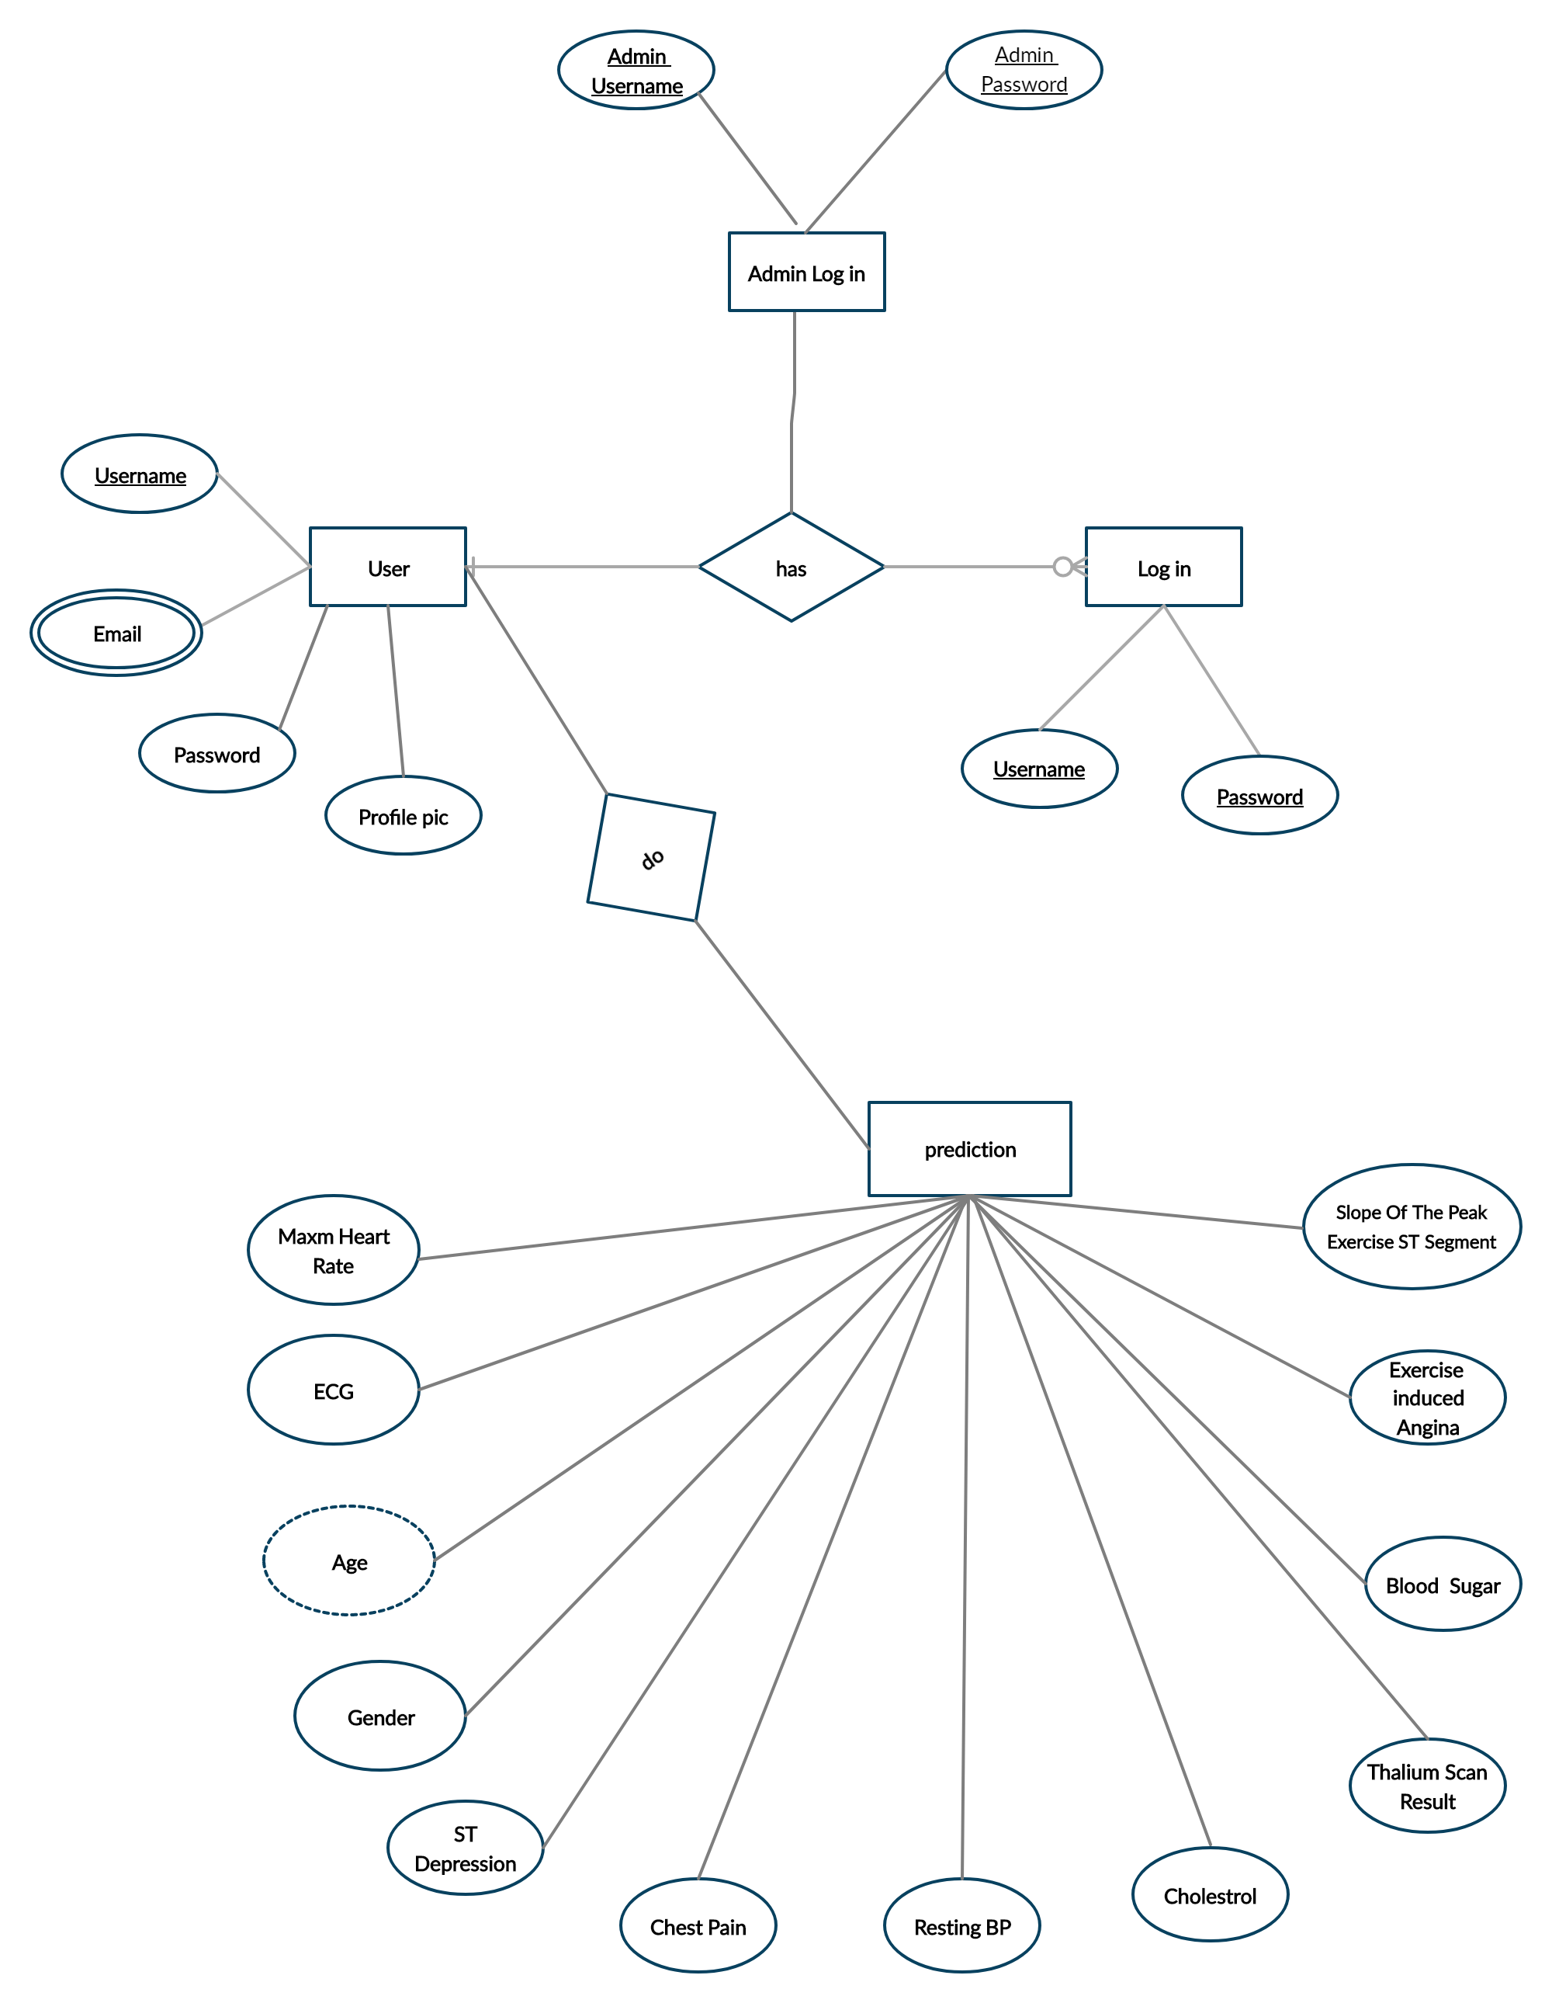

Fig: ER Diagram of Heart Disease Prediction System

* **Data flow diagram:**

Fig: Data Flow Diagram of Heart Disease Prediction System

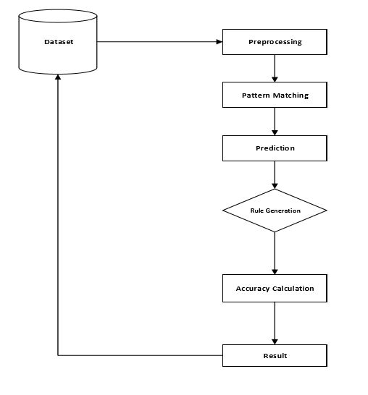

* **Activity diagram:**

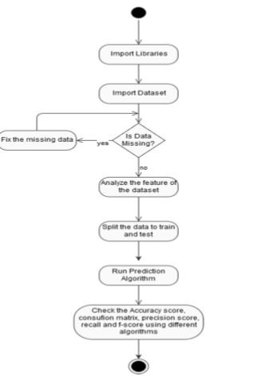

Fig: Activity Diagram of Heart Disease Prediction System

* **Sequence diagram:**

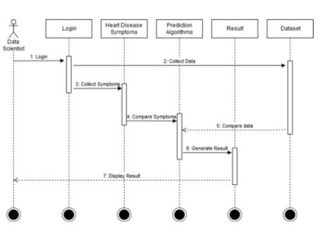

Fig: Sequence Diagram of Heart Disease Prediction System

Implementation

1. Modules:
2. **Data Analysis:**
3. Importing libraries
4. Data description
5. Analyzing the dataset

1. **Machine Learning:**

logistic_regression.py

svc.py

naive_bayes.py

decision_tree.py

XGB_classifier.py

random_forest.py

1. **Backend :**

1. **accounts:**
2. admin.py
3. forms.py
4. models.py
5. urls.py
6. views.py
7. **Heart-Disease-Prediction:**
8. settings.py
9. urls.py
10. **Predict_risk:**
11. admin.py
12. forms.py
13. models.py
14. urls.py
15. views.py
16. data_provider.py

1. **Frontend :**

1. **Static:**
2. recommendation.css
3. intro.css, etc
4. **Template:**
5. about.html
6. intro.html
7. login.html
8. profileview.html
9. recommendation.html
10. register.html
11. predict.html
12. Modules Description:
13. Data Analysis:
14. **Importing libraries:**

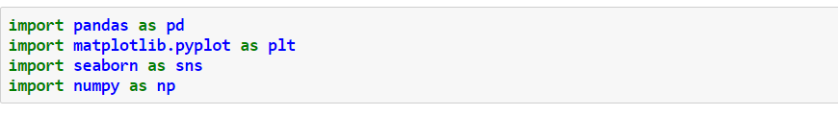

1. **Data description:**

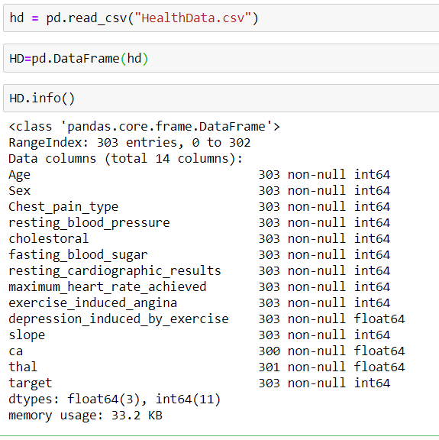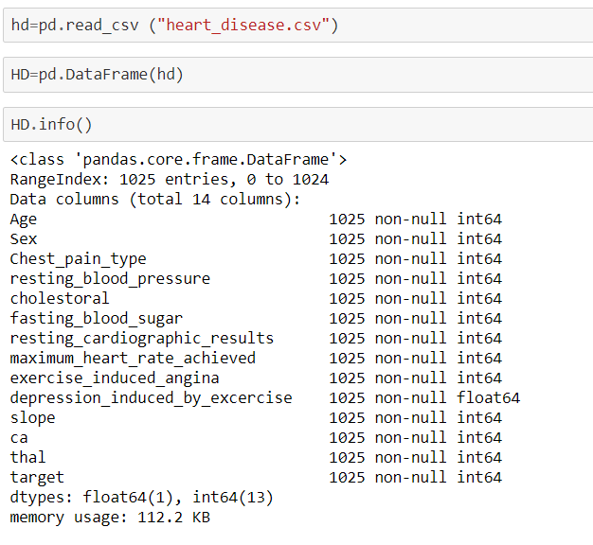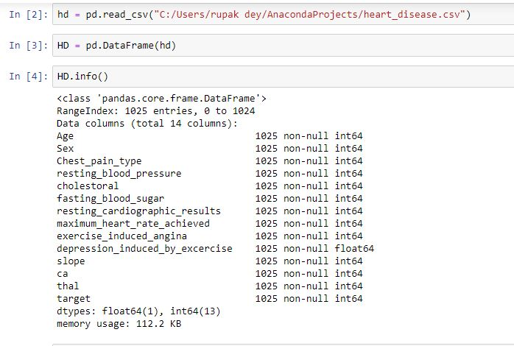

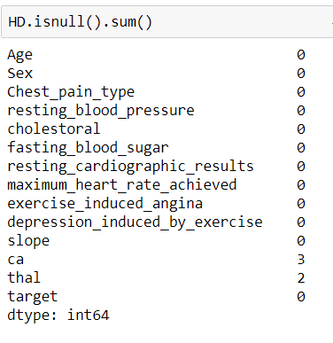

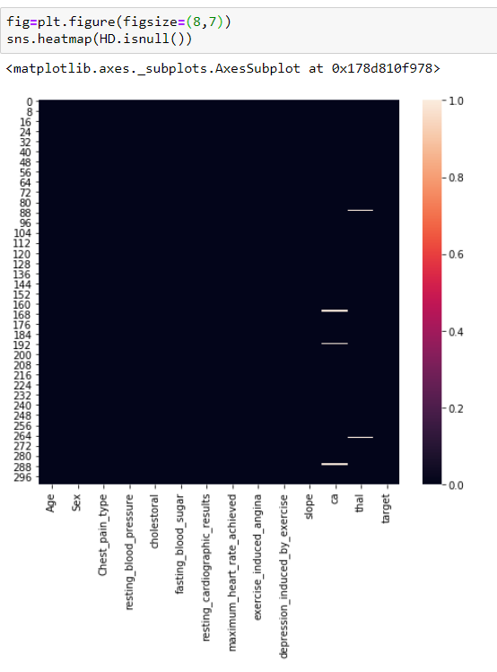

1. **Analyzing the dataset:**

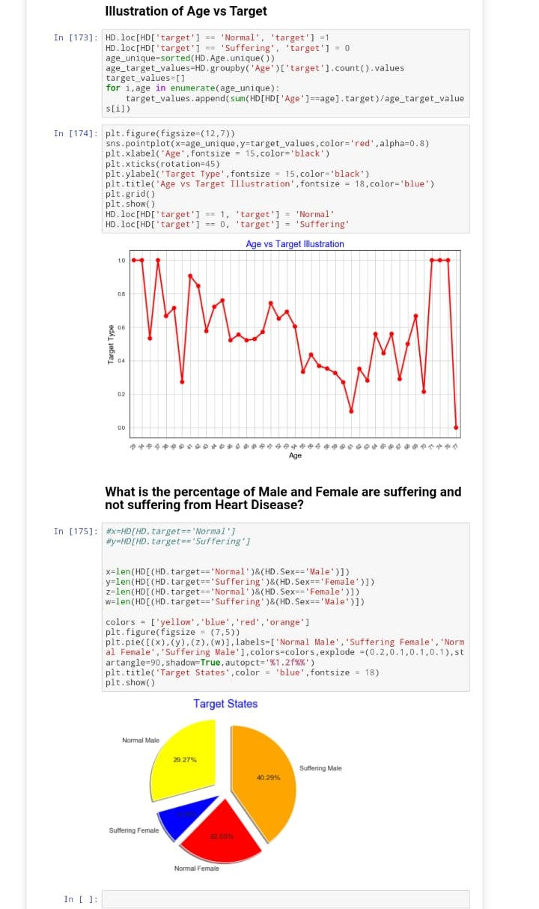

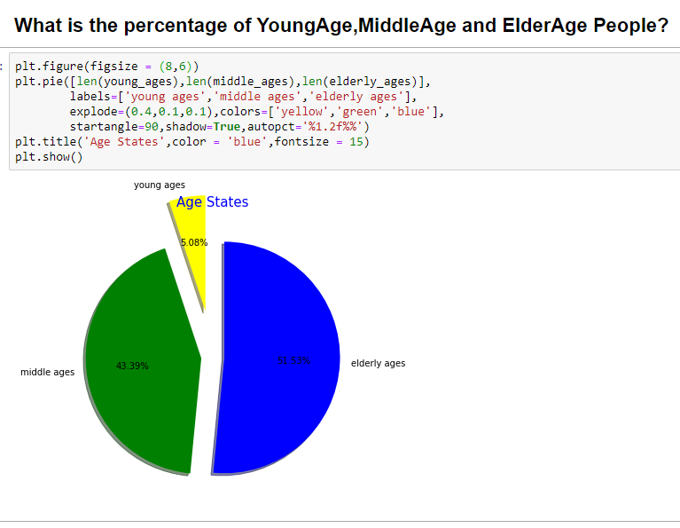

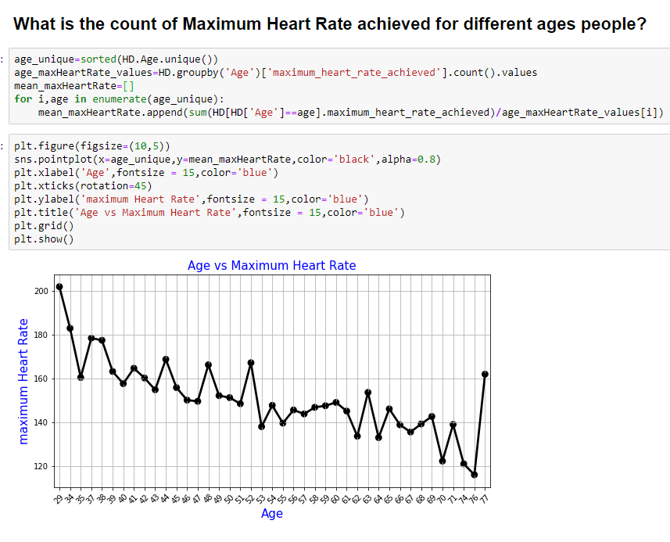

1. Machine Learning:
2. **Logistic Regression:**

**# Importing the dataset**

dataset=pd.read_csv(“heart_diseaseUpdate.csv”)

X = dataset.iloc[:,:-1].values

X = dataset.iloc[:, :-1].values

y = dataset.iloc[:, 13].values

**#handling missing data**

from sklearn.impute import SimpleImputer

imputer = SimpleImputer(missing_values=np.nan, strategy='mean')

imputer=imputer.fit(X[:,11:13])

X[:,11:13]=imputer.transform(X[:,11:13])

**#splitting dataset into training set and test set**

from sklearn.model_selection import train_test_split

X_train,X_test,Y_train,Y_test=train_test_split(X,y,test_size=0.20,random_state=5)

from sklearn.preprocessing import StandardScaler

sc_X=StandardScaler()

X_train=sc_X.fit_transform(X_train)

X_test=sc_X.transform(X_test)

**#Saving StandardScaler into pickle**

from sklearn.externals.joblib import dump, load

dump(sc_X,”predict_risk/production/std_scaler2.pkl”, compress=True)

**#fitting LR to training set**

from sklearn.linear_model import LogisticRegression

classifier =LogisticRegression(random_state=8)

classifier.fit(X_train,Y_train)

**#Saving the model to disk**

from sklearn.externals import joblib

filename = “predict_risk/production/Logistic_regression_model.pkl”

joblib.dump(classifier,filename)

**#Predict the test set results**

y_Class_pred=classifier.predict(X_test)

**#checking the accuracy for predicted results**

from sklearn.metrics import accuracy_score

yp = accuracy_score(Y_test,y_Class_pred)

print(yp)

**# Making the Confusion Matrix**

from sklearn.metrics import confusion_matrix

cm = confusion_matrix(Y_test, y_Class_pred)

**#Interpretation**

from sklearn.metrics import classification_report

print(classification_report(Y_test, y_Class_pred))

1. **Support Vector Classifier(SVC) :**

**# Importing the dataset**

dataset = pd.read_csv(“heart_diseaseUpdate.csv”)

X = dataset.iloc[:, :-1].values

y = dataset.iloc[:, 13].values

**#handling missing data**

from sklearn.impute import SimpleImputer

imputer = SimpleImputer(missing_values=np.nan, strategy='mean')

imputer=imputer.fit(X[:,11:13])

X[:,11:13]=imputer.transform(X[:,11:13])

**#splitting dataset into training set and test set**

from sklearn.model_selection import train_test_split

X_train,X_test,Y_train,Y_test=train_test_split(X,y,test_size=0.20,random_state=2)

**#feature scaling**

from sklearn.preprocessing import StandardScaler

sc_X=StandardScaler()

X_train=sc_X.fit_transform(X_train)

X_test=sc_X.transform(X_test)

**#Saving StandardScaler into pickle**

from sklearn.externals.joblib import dump, load

dump(sc_X,”predict_risk/production/std_scaler2.pkl”, compress=True)

**#SUPPORT VECTOR CLASSIFICATIONS**

**# Fitting SVM to the Training set**

classifier = SVC(kernel = 'rbf', random_state = 3 ,probability=True)

classifier.fit(X_train, Y_train)

from sklearn.externals import joblib

filename = “predict_risk/production/svc_model.pkl”

joblib.dump(classifier,filename)

**# Predicting the Test set results**

y_pred = classifier.predict(X_test)

from sklearn.metrics import accuracy_score

yp = accuracy_score(Y_test,y_pred)

print(yp)

**# Making the Confusion Matrix**

from sklearn.metrics import confusion_matrix

cm = confusion_matrix(Y_test, y_pred)

**#Interpretation:**

from sklearn.metrics import classification_report

print(classification_report(Y_test, y_pred))

1. **Naive Bayes :**

**# Importing the dataset**

dataset = pd.read_csv(“heart_diseaseUpdate.csv”)

X = dataset.iloc[:,:-1].values

y = dataset.iloc[:, 13].values

**#handling missing data**

from sklearn.impute import SimpleImputer

imputer = SimpleImputer(missing_values=np.nan, strategy='mean')

imputer=imputer.fit(X[:,11:13])

X[:,11:13]=imputer.transform(X[:,11:13])

**# Splitting the dataset into the Training set and Test set**

from sklearn.model_selection import train_test_split

X_train, X_test, y_train, y_test = train_test_split(X, y, test_size = 0.20, random_state = 3)

**# Feature Scaling**

from sklearn.preprocessing import StandardScaler

sc = StandardScaler()

X_train = sc.fit_transform(X_train)

X_test = sc.transform(X_test)

**#Saving StandardScaler file in pickle**

from sklearn.externals.joblib import dump, load

dump(sc,”predict_risk/production/std_scaler1.pkl”, compress=True)

**# Fitting Naive Bayes to the Training set**

from sklearn.naive_bayes import GaussianNB

classifier = GaussianNB()

classifier.fit(X_train, y_train)

#Saving the model in pickle

from sklearn.externals import joblib

filename = “predict_risk/production/naive_bayes_model.pkl”

joblib.dump(classifier,filename)

**# Predicting the Test set results**

y_pred = classifier.predict(X_test)

**#ACCURACY SCORE**

from sklearn.metrics import accuracy_score

yp = accuracy_score(y_test,y_pred)

print(yp)

**# Making the Confusion Matrix**

from sklearn.metrics import confusion_matrix

cm = confusion_matrix(y_test, y_pred)

**#Interpretation:**

from sklearn.metrics import classification_report

print(classification_report(y_test, y_pred))

1. **Decision tree:**

**# Importing the dataset**

dataset = pd.read_csv(“heart_diseaseUpdate.csv”)

X = dataset.iloc[:,:-1].values

y = dataset.iloc[:, 13].values

**#handling missing data**

from sklearn.impute import SimpleImputer

imputer = SimpleImputer(missing_values=np.nan, strategy='mean')

imputer=imputer.fit(X[:,11:13])

X[:,11:13]=imputer.transform(X[:,11:13])

**# Splitting the dataset into the Training set and Test set**

from sklearn.model_selection import train_test_split

X_train, X_test, y_train, y_test = train_test_split(X, y, test_size = 0.20, random_state = 3)

**#Feature Scaling**

from sklearn.preprocessing import StandardScaler

sc = StandardScaler()

X_train = sc.fit_transform(X_train)

X_test = sc.transform(X_test)

**#Saving StandardScaler file in pickle**

from sklearn.externals.joblib import dump, load

dump(sc,”predict_risk/production/std_scaler1.pkl”, compress=True)

**# Fitting Decision Tree Classification to the Training set**

from sklearn.tree import DecisionTreeClassifier

classifier = DecisionTreeClassifier(criterion = 'entropy', random_state = 5)

classifier.fit(X_train, y_train)

from sklearn.externals import joblib

filename = “predict_risk/production/decision_tree_model.pkl”

joblib.dump(classifier,filename)

**# Predicting the Test set results**

y_pred = classifier.predict(X_test)

**#ACCURACY SCORE**

from sklearn.metrics import accuracy_score

yp = accuracy_score(y_test,y_pred)

print(yp)

**#CONFUSION MATRIX**

from sklearn.metrics import classification_report, confusion_matrix

cm=confusion_matrix(y_test, y_pred)

**#Interpretation:**

from sklearn.metrics import classification_report

print(classification_report(y_test, y_pred))

1. **XGB Classifier:**

**# Importing the dataset**

dataset = pd.read_csv(“heart_diseaseUpdate.csv”)

X = dataset.iloc[:,:-1].values

y = dataset.iloc[:, 13].values

**#handling missing data**

from sklearn.impute import SimpleImputer

imputer = SimpleImputer(missing_values=np.nan, strategy='mean')

imputer=imputer.fit(X[:,11:13])

X[:,11:13]=imputer.transform(X[:,11:13])

**# Splitting the dataset into the Training set and Test set**

from sklearn.model_selection import train_test_split

X_train, X_test, y_train, y_test = train_test_split(X, y, test_size=0.3,random_state=3)

**#Feature Scaling**

from sklearn.preprocessing import StandardScaler

sc1 = StandardScaler()

X_train = sc1.fit_transform(X_train)

X_test = sc1.transform(X_test)

**#Saving StandardScaler file in pickle**

from sklearn.externals.joblib import dump, load

dump(sc1,”predict_risk/production/std_scaler3.pkl”, compress=True)

**# Fitting XgBoost Classifier to the Training set**

from xgboost import XGBClassifier

classifier = XGBClassifier()

classifier.fit(X_train, y_train)

filename = “predict_risk/production/xgboost.pkl”

joblib.dump(classifier,filename)

**# Predicting the Test set results**

y_pred = classifier.predict(X_test)

**#ACCURACY SCORE**

from sklearn.metrics import accuracy_score

yp = accuracy_score(y_test,y_pred)

print(yp)

**#CONFUSION MATRIX**

from sklearn.metrics import classification_report, confusion_matrix

cm=confusion_matrix(y_test, y_pred)

**#Interpretation:**

from sklearn.metrics import classification_report

print(classification_report(y_test, y_pred))

1. **Random Forest :**

**# Importing the dataset**

dataset = pd.read_csv(“heart_diseaseUpdate.csv”)

X = dataset.iloc[:,:-1].values

y = dataset.iloc[:, 13].values

**#handling missing data**

from sklearn.impute import SimpleImputer

imputer = SimpleImputer(missing_values=np.nan, strategy='mean')

imputer=imputer.fit(X[:,11:13])

X[:,11:13]=imputer.transform(X[:,11:13])

**# Splitting the dataset into the Training set and Test set**

from sklearn.model_selection import train_test_split

X_train, X_test, y_train, y_test = train_test_split(X, y, test_size=0.30,random_state=9)

**#Feature Scaling**

from sklearn.preprocessing import StandardScaler

sc1 = StandardScaler()

X_train = sc1.fit_transform(X_train)

X_test = sc1.transform(X_test)

**#saving StandardScaler file in pickle**

from sklearn.externals.joblib import dump, load

dump(sc1,”predict_risk/production/std_scaler3.pkl”, compress=True)

**# Fitting Decision Tree Classification to the Training set**

from sklearn.ensemble import RandomForestClassifier

classifier = RandomForestClassifier(random_state=3)

classifier.fit(X_train, y_train)

from sklearn.externals import joblib

filename = “predict_risk/production/random_forest_model.pkl”

joblib.dump(classifier,filename)

**# Predicting the Test set results**

y_pred = classifier.predict(X_test)

**#ACCURACY SCORE**

from sklearn.metrics import accuracy_score

yp = accuracy_score(y_test,y_pred)

print(yp)

**#CONFUSION MATRIX**

from sklearn.metrics import classification_report, confusion_matrix

cm=confusion_matrix(y_test, y_pred)

**#Interpretation:**

from sklearn.metrics import classification_report

print(classification_report(y_test, y_pred))

1. Back end:
2. **accounts:** 
   1. **admin.py:**

from django.contrib import admin

from accounts.models import UserProfileInfo

class UserProfile(admin.ModelAdmin):

list_display = ('user', 'profile_pic')

admin.site.register(UserProfileInfo, UserProfile)

* 1. **forms.py:**

from django import forms

from .models import UserProfileInfo

from django.contrib.auth.models import User

class UserForm(forms.ModelForm):

username = forms.CharField(widget=forms.TextInput(

attrs={'class':'form-control','placeholder':'Enter username'}), required=True, max_length=50)

email = forms.CharField(widget=forms.EmailInput(

attrs={'class': 'form-control', 'placeholder': 'Enter Email Id'}), required=True, max_length=50)

password = forms.CharField(widget=forms.PasswordInput(

attrs={'class':'form-control','placeholder':'Enter password'} ), required=True, max_length=50)

confirm_password=forms.CharField(widget=forms.PasswordInput(attrs={'class': 'form-control', 'placeholder': 'Confirm password'}), required=True, max_length=50)

class Meta:

model = User

fields = ('username', 'email', 'password')

def clean(self):

cleaned_data = super(UserForm, self).clean()

password = cleaned_data.get("password")

confirm_password=cleaned_data.get("confirm_password")

if password != confirm_password:

raise forms.ValidationError("Password and Confirm password does not match")

class UserProfileInfoForm(forms.ModelForm):

class Meta:

model = UserProfileInfo

fields = ('profile_pic',)

class UpdateProfileForm(forms.ModelForm):

class Meta:

model = User

fields = ('username', 'first_name', 'last_name', 'email')

widgets={'username': forms.TextInput(attrs={'readonly': 'True'})}

* 1. **models.py:**

from django.db import models

from django.contrib.auth.models import User

from django.conf.urls import url

from django.shortcuts import resolve_url

class UserProfileInfo(models.Model):

user=models.OneToOneField(User, on_delete=models.CASCADE, related_name='profile')

profile_pic=models.ImageField(upload_to='profile_pics', default="1.jpg")

def __str__(self):

return self.user.username

* 1. **urls.py:**

from django.conf.urls import url

from . import views

app_name = 'accounts'

urlpatterns=[

url(r'^register/$', views.register, name='register'),

url(r'^logout/$', views.user_logout,name='logout'),

url(r'^recommendation/$',views.predict_recomm, name='recommendation'),

url(r'^profile/(?P<pk>\d+)/$', views.ProfileDetailView.as_view(), name='profile'),

]

* 1. **views.py:**

from django.shortcuts import render

from .forms import UserForm, UserProfileInfoForm, UpdateProfileForm

from django.views.generic import DetailView,UpdateView,TemplateView

from django.contrib.auth import authenticate, login, logout

from django.http import HttpResponseRedirect, HttpResponse

from django.urls import reverse

from django.contrib.auth.mixins import LoginRequiredMixin

from django.contrib.auth.decorators import login_required

from .models import UserProfileInfo, User

from django.shortcuts import get_object_or_404

import random

@login_required

def user_logout(request):

request.session.flush()

logout(request)

return HttpResponseRedirect(reverse('user_login'))

class Aboutpageview(TemplateView):

template_name='accounts/about.html';

class Intropageview(TemplateView):

template_name='accounts/intro.html';

def register(request):

registered = False

if request.method == 'POST':

user_form = UserForm(data=request.POST)

profile_form = UserProfileInfoForm(data=request.POST)

if user_form.is_valid() and profile_form.is_valid():

user = user_form.save()

user.set_password(user.password)

user.save()

profile = profile_form.save(commit=False)

profile.user = user

if 'profile_pic' in request.FILES:

profile.profile_pic = request.FILES['profile_pic']

profile.save()

registered = True

else:

print(user_form.errors, profile_form.errors)

if registered:

return HttpResponseRedirect(reverse('user_login'))

else:

user_form = UserForm()

profile_form = UserProfileInfoForm()

return render(request, 'accounts/register.html',

{'user_form':user_form,'profile_form': profile_form, 'registered': registered})

def user_login(request):

if request.method == 'POST':

username = request.POST.get('username')

password = request.POST.get('password')

user=authenticate(username=username, password=password)

if user:

if user.is_active:

login(request, user)

request.session['user_id'] = user.profile.pk

return HttpResponseRedirect(reverse('predict:predict', kwargs={'pk': user.profile.pk}))

else:

return HttpResponse("Account not active")

else:

print("Tried login and failed")

print("username:{} and password: {}".format(username, password))

return HttpResponse("Invalid login details supplied!")

else:

return render(request, 'accounts/login.html', {})

class ProfileDetailView(LoginRequiredMixin, DetailView):

login_url = '/'

redirect_field_name = '/'

model = UserProfileInfo

template_name = 'accounts/profileview.html'

def get_context_data(self, **kwargs):

if self.request.session.has_key('user_id'):

u_id = self.request.session['user_id']

context=super(ProfileDetailView, self).get_context_data(**kwargs)

context['user_id'] = u_id

return context

1. **heart-disease-prediction:**
2. **settings.py:**

import os

**#Build paths inside the project like this:** os.path.join(BASE_DIR, ...)

BASE_DIR=os.path.dirname(os.path.dirname(os.path.abspath(__file__)))

**# Application definition**

INSTALLED_APPS = [

'django.contrib.admin',

'django.contrib.auth',

'django.contrib.contenttypes',

'django.contrib.sessions',

'django.contrib.messages',

'django.contrib.staticfiles',

'accounts', 'predict_risk',

]

ROOT_URLCONF = 'heart_disease_prediction.urls'

TEMPLATES = [

{

'BACKEND': 'django.template.backends.django.DjangoTemplates',

'DIRS': [os.path.join(BASE_DIR, 'accounts/templates'),os.path.join(BASE_DIR, 'predict_risk/templates')],

'APP_DIRS': True,

'OPTIONS': {

'context_processors': [

'django.template.context_processors.debug',

'django.template.context_processors.request',

'django.contrib.auth.context_processors.auth', 'django.contrib.messages.context_processors.messages',

],

},

},

]

**# Database**

#https://docs.djangoproject.com/en/2.1/ref/settings/databases

DATABASES = {

'default': {

'ENGINE': 'django.db.backends.sqlite3',

'NAME': os.path.join(BASE_DIR, 'db.sqlite3'),

}

}

**# Password validation**

#https://docs.djangoproject.com/en/2.1/ref/settings/#auth-password-validators

AUTH_PASSWORD_VALIDATORS = [

{

'NAME': 'django.contrib.auth.password_validation.UserAttributeSimilarityValidator',

},

{

'NAME': 'django.contrib.auth.password_validation.MinimumLengthValidator',

},

{

'NAME': 'django.contrib.auth.password_validation.CommonPasswordValidator',

},

{

'NAME': 'django.contrib.auth.password_validation.NumericPasswordValidator',

},

]

**# Internationalization**

# https://docs.djangoproject.com/en/2.1/topics/i18n/

LANGUAGE_CODE = 'en-us'

TIME_ZONE = 'Asia/Kolkata'

USE_I18N = True

USE_L10N = True

USE_TZ = True

LOGIN_URL='/'

LOGIN_REDIRECT_URL = '/'

**# Static files (CSS, JavaScript, Images)**

#https://docs.djangoproject.com/en/2.1/howto/static-files/

STATIC_DIR = os.path.join(BASE_DIR,'accounts/static')

STATICFILES_DIRS = [

STATIC_DIR

]

STATIC_URL = '/static/'

**#media**

MEDIA_DIR = os.path.join(BASE_DIR, "accounts/media")

MEDIA_ROOT = MEDIA_DIR

MEDIA_URL = '/media/'

1. **urls.py:**

from django.contrib import admin

from django.urls import path

from django.conf.urls import url,include

from accounts.views import Aboutpageview,Intropageview

from accounts import views

from heart_disease_prediction import settings

from django.contrib.staticfiles.urls import static

from django.contrib.staticfiles.urls import staticfiles_urlpatterns

urlpatterns = [

path('admin/', admin.site.urls),

url(r'^$', views.user_login,name='user_login'),

url(r'^about/', Aboutpageview.as_view(),name='about'),

url(r'^intro/', Intropageview.as_view(),name='intro'),

url(r'^accounts/', include('accounts.urls')),

url(r'^predict/', include('predict_risk.urls')),

]

urlpatterns += staticfiles_urlpatterns()

urlpatterns+=static(settings.MEDIA_URL, document_root=settings.MEDIA_ROOT)

1. **predict_risk :**
2. **admin.py**

from django.contrib import admin

from predict_risk.models import Predictions

from django import forms

class Prediction(admin.ModelAdmin): list_display=('profile','age','sex','cp','resting_bp','serum_cholesterol','fasting_blood_sugar','resting_ecg','max_heart_rate','exercise_induced_angina','st_depression','st_slope','number_of_vessels','thallium_scan_results','predicted_on','num')

admin.site.register(Predictions,Prediction)

1. **forms.py**

from django import forms

from predict_risk.models import Predictions

class Predict_Form(forms.ModelForm):

class Meta:

model = Predictions

fields = ('age','sex','cp','resting_bp','serum_cholesterol','fasting_blood_sugar','resting_ecg','max_heart_rate', 'exercise_induced_angina','st_depression','st_slope','number_of_vessels','thallium_scan_results')

widgets = {'age': forms.TextInput(attrs={'class': 'form-control'}),

'sex': forms.Select(attrs={'class': 'form-control'}),

'cp': forms.Select(attrs={'class': 'form-control'}),

'resting_bp':forms.TextInput(attrs={'class': 'form-control'}), 'serum_cholesterol':forms.TextInput(attrs={'class': 'form-control'}), 'fasting_blood_sugar':forms.Select(attrs={'class': 'form-control'}), 'resting_ecg':forms.Select(attrs={'class': 'formcontrol'}),'max_heart_rate':forms.TextInput(attrs={'class':'formcontrol'}),'exercise_induced_angina':forms.Select(attrs={'class':'formcontrol'}),'st_depression':forms.TextInput(attrs={'class': 'form-control'}),'st_slope':forms.Select(attrs={'class': 'formcontrol'}),'number_of_vessels':forms.Select(attrs={'class':'formcontrol'}),'thallium_scan_results':forms.Select(attrs={'class': 'form-control'}),

}

1. **models.py**

from django.db import models

from accounts.models import UserProfileInfo

from django.utils import timezone

from django.urls import reverse

# Create your models here.

sex_choices=((0, 'Female'),(1, 'Male'))

cp_choice=((0,'None'),(1, 'Typical Angina'),(2, 'Atypical Angina'),(3, 'Non-Angina'),(4, 'Asymptomatic'))

fasting_blood_sugar_choices=((1,'> 120 mg/dl'),((0,'< 120 mg/dl')))

resting_ecg_choices=((0, 'Normal'),(1, 'Having ST-T wave abnormality'),(2, 'hypertrophy'))

exercise_induced_angina_choices=((0, 'No'),(1, 'Yes'))

st_slope_choices=((1, 'Upsloping'),(2, 'Flat'),(3, 'Down Sloping'))

number_of_vessels_choices=((0, 'None'),(1, 'One'),(2, 'Two'),(3, 'Three'))

thallium_scan_results_choices=((1, 'Normal'),(2, 'Fixed Defect'),(3, 'Reversible Defect'))

class Predictions(models.Model):

profile = models.ForeignKey(UserProfileInfo, on_delete=models.CASCADE, related_name='predict')

age = models.IntegerField()

sex = models.IntegerField(choices=sex_choices, default=0)

cp = models.IntegerField(choices=cp_choice,default=0)

resting_bp = models.IntegerField()

serum_cholesterol = models.IntegerField()

fasting_blood_sugar = models.IntegerField(choices=fasting_blood_sugar_choices,default=0)

resting_ecg = models.IntegerField(choices=resting_ecg_choices,default=0)

max_heart_rate = models.IntegerField()

exercise_induced_angina = models.IntegerField(choices=exercise_induced_angina_choices,default=0)

st_depression = models.DecimalField(max_digits=4, decimal_places=2)

st_slope = models.IntegerField(choices=st_slope_choices)

number_of_vessels = models.IntegerField(choices=number_of_vessels_choices)

thallium_scan_results = models.IntegerField(choices=thallium_scan_results_choices)

predicted_on = models.DateTimeField(default=timezone.now)

num=models.IntegerField()

def get_absolute_url(self):

return reverse('predict:predict', kwargs={'pk': self.profile.pk})

1. **urls.py :**

from django.conf.urls import url

from . import views

app_name='predict'

urlpatterns=[

url(r'^(?P<pk>\d+)$',views.PredictRisk,name='predict'),

]

1. **views.py :**

import csv,io

from django.shortcuts import render

from .forms import Predict_Form

from predict_risk.data_provider import *

from accounts.models import UserProfileInfo

from django.shortcuts import get_object_or_404, redirect, render

from django.http import HttpResponseRedirect, HttpResponse

from django.contrib.auth.decorators import login_required,permission_required

from django.urls import reverse

from django.contrib import messages

@login_required(login_url='/')

def PredictRisk(request,pk):

predicted = False

predictions={}

if request.session.has_key('user_id'):

u_id = request.session['user_id']

if request.method == 'POST':

form = Predict_Form(data=request.POST)

profile = get_object_or_404(UserProfileInfo, pk=pk)

if form.is_valid():

features = [[ form.cleaned_data['age'], form.cleaned_data['sex'], form.cleaned_data['cp'], form.cleaned_data['resting_bp'], form.cleaned_data['serum_cholesterol'],

form.cleaned_data['fasting_blood_sugar'], form.cleaned_data['resting_ecg'], form.cleaned_data['max_heart_rate'], form.cleaned_data['exercise_induced_angina'],

form.cleaned_data['st_depression'], form.cleaned_data['st_slope'], form.cleaned_data['number_of_vessels'], form.cleaned_data['thallium_scan_results']]]

standard_scalar1 = GetStandardScalarForHeart1()

standard_scalar2 = GetStandardScalarForHeart2()

standard_scalar3 = GetStandardScalarForHeart3()

features1 = standard_scalar1.transform(features)

features2= standard_scalar2.transform(features)

features3= standard_scalar3.transform(features)

SVCClassifier,LogisticRegressionClassifier,NaiveBayesClassifier,DecisionTreeClassifier,XgboostClassifier,RandomForestClassifier=GetAllClassifiersForHeart()

predictions = {'SVC':str(SVCClassifier.predict(features2)[0]), 'LogisticRegression':str(LogisticRegressionClassifier.predict(features2)[0]),

'NaiveBayes': str(NaiveBayesClassifier.predict(features1)[0]),

'DecisionTree': str(DecisionTreeClassifier.predict(features1)[0]),

'Boostxg': str(XgboostClassifier.predict(features3)[0]),

'RandomForest': str(RandomForestClassifier.predict(features3)[0]),

}

pred = form.save(commit=False) l=[predictions['SVC'],predictions['LogisticRegression'],predictions['NaiveBayes'],predictions['DecisionTree'],predictions['RandomForest']]

count=l.count('1')

result=False

if count>=3:

result=True

pred.num=1

else:

pred.num=0

pred.profile = profile

pred.save()

predicted = True

colors={}

if predictions['SVC']=='0':

colors['SVC']="table-success"

elif predictions['SVC']=='1':

colors['SVC']="table-danger"

if predictions['LogisticRegression']=='0':

colors['LR']="table-success"

else:

colors['LR']="table-danger"

if predictions['NaiveBayes']=='0':

colors['NB']="table-success"

else:

colors['NB']="table-danger"

if predictions['DecisionTree']=='0':

colors['DT']="table-success"

else:

colors['DT']="table-danger"

if predictions['Boostxg']=='0':

colors['XGB']="table-success"

else:

colors['XGB']="table-danger"

if predictions['RandomForest']=='0':

colors['RF']="table-success"

else:

colors['RF']="table-danger"

if predicted:

return render(request, 'predict.html',

{'form': form,'predicted': predicted,'user_id':u_id,'predictions':predictions,'result':result,'colors':colors})

else:

form = Predict_Form()

return render(request, 'predict.html',

{'form': form,'predicted': predicted,'user_id':u_id,'predictions':predictions})

1. **data provider.py**

import os

import klepto

import pickle, gzip

from sklearn.externals import joblib

config = {

'heart': {

'SVC': 'production/svc_model.pkl',

'LogisticRegression': 'production/Logistic_regression_model.pkl',

'NaiveBayes': 'production/naive_bayes_model.pkl',

'DecisionTree':'production/decision_tree_model.pkl',

'Boost':'production/xgboost.pkl',

'RandomForest':'production/random_forest_model.pkl',

'scaler_file1': 'production/std_scaler1.pkl',

'scaler_file2': 'production/std_scaler2.pkl',

'scaler_file3':'production/std_scaler3.pkl',

}}

dir = os.path.dirname(__file__)

def GetJobLibFile(filepath):

if os.path.isfile(os.path.join(dir, filepath)):

return joblib.load(os.path.join(dir, filepath))

return None

def GetPickleFile(filepath):

if os.path.isfile(os.path.join(dir, filepath)):

return joblib.load( open(os.path.join(dir, filepath), "rb" ) )

else:

return None

def GetStandardScalarForHeart1():

return GetPickleFile(config['heart']['scaler_file1'])

def GetStandardScalarForHeart2():

return GetPickleFile(config['heart']['scaler_file2'])

def GetStandardScalarForHeart3():

return GetPickleFile(config['heart']['scaler_file3'])

def GetSVCClassifierForHeart():

return GetJobLibFile(config['heart']['SVC'])

def GetLogisticRegressionClassifierForHeart():

return GetJobLibFile(config['heart']['LogisticRegression'])

def GetNaiveBayesClassifierForHeart():

return GetJobLibFile(config['heart']['NaiveBayes'])

def GetDecisionTreeClassifierForHeart():

return GetJobLibFile(config['heart']['DecisionTree'])

def GetXgboostForHeart():

return GetJobLibFile(config['heart']['Boost'])

def GetRandomForestClassifierForHeart():

return GetJobLibFile(config['heart']['RandomForest'])

def GetAllClassifiersForHeart():

return (GetSVCClassifierForHeart(),GetLogisticRegressionClassifierForHeart(),GetNaiveBayesClassifierForHeart(),GetDecisionTreeClassifierForHeart(),GetXgboostForHeart(),GetRandomForestClassifierForHeart())

1. Front end:
2. Static CSS files :
3. **recommendation.css :**

* {

margin: 0;

padding: 0;

color: #555;

}

.main {

/* width: 790px;

height: 90vh; */

margin: 0 auto;;

position: relative;

overflow: hidden;

background: #fdfdfd;

}

.header {

position: sticky;

top: 0;

z-index: 10;

}

.navbar-brand{

height: 40px;

padding-left: 25px;

}

.navbar-nav li{

padding: 0 10px;

}

.navbar-nav li a{

float: inherit;

text-align: left;

color: #555;

}

#nav-bar ul li a:hover{

color: #007bff!important;

}

.navbar{

background: #fff;

}

.navbar-toggler{

border: none!important;

}

.nav-link{

color: #555!important;

font-weight: 600;

font-family: sans-serif;

font-display: fallback;

font-size: 17px;

}

.nav-link:hover {

color: #007bff!important;

}

.body

{

margin: 0;

padding: 0;

box-sizing: border-box;

font-family: 'Poppins', sans-serif;

}

.body

{

display: flex;

justify-content: center;

align-items: center;

min-height: 662px;

background: #F0EDFD;

}

.container

{

position: relative;

/* width: 1800px; */

width: 100%;

display: flex;

justify-content: space-between;

align-items: center;

border-spacing: 20px;

border-radius: 20px;

}

.container .box

{

position: relative;

width: 340px;

height: 440px;

display: flex;

justify-content: space-between;

align-items: center;

transition: 0.5s;

}

.container:hover .box

{

opacity: 0.1;

transform: scale(0.9);

filter: blur(5px);

}

.container .box:hover

{

opacity: 1;

transform: scale(1);

filter: blur(0);

}

.container .box:before

{

content: '';

position: absolute;

top: 0px;

left: 0px;

width: 100%;

height: 100%;

filter: url(#wavy);

}

.container .box:nth-child(1):before

{

background: #777;

}

.container .box:nth-child(2):before

{

background: #262626;

}

.container .box:nth-child(3):before

{

background: #339;

}

.container .box:nth-child(4):before

{

background: #0f0;

}

.container .box .content

{

position: absolute;

padding: 10px;

text-align: center;

color: #111;

transition: 0.5s;

}

.container .box .content h2

{

padding-top: 5px;

font-size: 2em;

}

.container .box .content h4

{

font-size: 20px;

text-align: center;

overflow: hidden;

justify-content: center;

color: #fff;

}

svg

{

width: 0;

height: 0;

}

1. **Intro.css :**

.{

padding: 0;

margin: 0;

box-sizing: border-box;

}

html{

background-color: #fff;

color: #555;

font-family: 'Lato','sans-serif';

font-size: 20px;

font-weight: 300px;

text-rendering: optimizeLegibility;

}

.row{

max-width: 1140px;

margin: 0 auto;

}

section {

padding: 50px 0;

}

.box {

padding: 1%;

}

.page-header {

height: 100vh;

max-height: 1050px;

padding: 0;

color: #FFFFFF;

position: relative;

background-position: center center;

background-size: cover;

}

.page-header .page-header-image {

position: absolute;

background-size: cover;

background-position: center center;

width: 100%;

height: 100%;

z-index: -1;

}

.page-header footer {

position: absolute;

bottom: 0;

width: 100%;

}

.page-header .container {

height: 100%;

z-index: 1;

text-align: center;

position: relative;

}

.page-header .container .content-center {

position: absolute;

top: 50%;

left: 50%;

-ms-transform: translate(-50%, -50%);

-webkit-transform: translate(-50%, -50%);

transform: translate(-50%, -50%);

text-align: left;

float: left;

text-transform: uppercase;

text-shadow: 8px;

padding: 0 15px;

color: #FFFFFF;

width: 100%;

max-width: 880px;

}

.page-header .category,

.page-header .description {

color: rgba(255, 255, 255, 0.5);

}

.page-header.page-header-small {

height: 100vh;

max-height: 740px;

}

.page-header:after,

.page-header:before {

position: absolute;

z-index: 0;

width: 100%;

height: 100%;

display: block;

left: 0;

top: 0;

content: "";

}

.page-header:before {

background-color: rgba(0, 0, 0, 0.5);

}

.page-header[filter-color="orange"] {

background: rgba(44, 44, 44, 0.2);

background: -webkit-linear-gradient(90deg, rgba(44, 44, 44, 0.2), rgba(224, 23, 3, 0.6));

background: -o-linear-gradient(90deg, rgba(44, 44, 44, 0.2), rgba(224, 23, 3, 0.6));

background: -moz-linear-gradient(90deg, rgba(44, 44, 44, 0.2), rgba(224, 23, 3, 0.6));

background: linear-gradient(0deg, rgba(44, 44, 44, 0.2), rgba(224, 23, 3, 0.6));

}

.page-header .container {

z-index: 2;

}

.footer{

padding: 24px 0;

display: grid;

padding-top: 30px;

padding-bottom: 70px;

}

.footer .about-us {

padding-left: 50px;

text-align: center;

color: #fff;

font-weight: normal;

text-transform: uppercase;

}

.footer .about-us p a {

color: #E69FF4;

}

.footer .about-us p a:hover {

color: #D7F4A4;

font-weight: bolder;

}

.footer {

padding: 24px 0;

padding-bottom: 70px;

}

.footer.footer-default {

background-color: #13392A;

}

.footer .copyright {

font-size: 0.971em;

color: #fff;

text-align: center;

}

footer .move-up{

position: absolute;

float: right;

right: 6%;

top: 50%;

}

footer .move-up span:hover{

color: var(--white);

cursor: pointer;

}

.section-features h1, h2 ,h3

{

font-weight: 300;

text-transform: uppercase;

}

.section-features h1 {

margin-top: 0;

margin-bottom: 20px;

color: #fff;

font-size: 200%;

word-spacing: 4px;

letter-spacing: 1px;

}

.section-features h2 {

font-size: 180%;

word-spacing: 2px;

text-align: center;

margin-top: 70px;

margin-bottom: 30px;

letter-spacing: 1px;

}

.section-features h3 {

font-size: 110%;

margin-bottom: 15px;

}

.section-features h2:after {

display: block;

height: 2px;

background-color: #e67e22;

content: " ";

width: 100px;

margin: 0 auto;

margin-top: 30px;

}

.section-features .long-copy {

line-height: 145%;

width: 70%;

margin-left: 15%;

text-align: justify;

}

.section-features .box p {

font-size: 90%;

line-height: 145%;

}

.section-features .icon-big {

font-size: 350%;

display: block;

color: #e67e22;

margin-bottom: 10px;

}

.btn:link,

.btn-visited {

display: inline-block;

padding: 10px 30px;

font-weight: 300;

text-decoration: none;

border-radius: 200px;

transition: background-color 0.2s, border 0.2s, color 0.2s;

}

.btn:hover,

.btn-active {

background-color: #cf6d17;

}

.btn-full:link,

.btn-full:visited {

background-color: #e67e22;

border: 1px solid #e67e22;

color: #fff;

margin-right: 15px;

}

.btn-ghost:link,

.btn-ghost:visited {

border: 1px solid #fff;

color: #fff;

}

.btn-full:hover,

.btn-full:active {

background-color: #cf6d17;

border: 1px solid #cf6d17;

}

.btn-ghost:hover,

.btn-ghost:active {

border: 1px solid #cf6d17;

color: #fff;

text-transform: uppercase;

text-shadow: 20%;

text-overflow: clip;

font-weight: bold;

}

header{

height: 100vh;

background-size: cover;

background-position: center;

}

.hero-text-box{

position: absolute;

width: 1140px;

top: 50%;

left: 50%;

text-align: left;

float: left;

transform: translate(-50%, -50%);

}

.hero-text-box h1{

color: #fff;

font-weight: 50px;

text-transform: uppercase;

}

.hero-text-box a{

color: #fff;

font-weight: bold;

}

.logo{

height: 100px;

width: auto;

float: left;

margin-top: 20px;

}

.main-nav{

float: right;

list-style: none;

margin-top: 55px;

}

.main-nav li {

display: inline-block;

margin-left: 40px;

}

.main-nav li a:link,

.main-nav li a:visited {

padding: 8px 0;

color: #fff;

text-decoration: none;

text-transform: uppercase;;

font-size: 90%;

border-bottom: 2px solid transparent;

transition: border-bottom 0.2s;

}

.main-nav li a:hover,

.main-nav li a:active {

border-bottom: 2px solid #e67e22;

}

.section-features .long-copy {

margin-bottom: 60px;

}

.section-features .long-copy .bold{

text-align: center;

width: 50%;

margin-left: 30px;

}

.head h1, h2 ,h3

{

font-weight: 300;

text-transform: uppercase;

}

.head h1 {

margin-top: 0;

margin-bottom: 20px;

color: #fff;

font-size: 200%;

word-spacing: 4px;

letter-spacing: 1px;

}

.head h2 {

font-size: 180%;

word-spacing: 2px;

text-align: center;

margin-bottom: 30px;

letter-spacing: 1px;

}

.head h3 {

font-size: 110%;

margin-bottom: 15px;

}

.head h2:after {

display: block;

height: 2px;

background-color: #e67e22;

content: " ";

width: 100px;

margin: 0 auto;

margin-top: 30px;

}

.hover h2 {

font-size: 180%;

word-spacing: 2px;

text-align: center;

margin-bottom: 30px;

letter-spacing: 1px;

}

.hover h3 {

font-size: 110%;

margin-bottom: 15px;

}

.hover h2:after {

display: block;

height: 2px;

background-color: #e67e22;

content: " ";

width: 100px;

margin: 0 auto;

margin-top: 30px;

}

.hover{

padding: 0;

display: flex;

justify-content: center;

align-items: center;

min-height: 100vh;

font-family: 'Poppins', sans-serif;

background: #fff;

margin-bottom: 30px;

}

.hover .container{

width: 1200px;

display: grid;

grid-template-columns: repeat(auto-fit, minmax(350px, 1fr));

grid-gap: 15px;

margin: 0 auto;

}

.hover .container .card{

position: relative;

width: 300px;

height: 400px;

margin: 0 auto;

background: #fff;

box-shadow: 0 15px 60px rgba(0, 0, 0, 0.5);

}

.hover .container .card .face{

position: absolute;

bottom: 0;

left: 0;

width: 100%;

height: 100%;

display: flex;

justify-content: center;

align-items: center;

}

.hover .container .card .face.face1{

box-sizing: border-box;

padding: 20px;

}

.hover .container .card .face.face1:nth-child(1)

.hover .container .card .face.face1 h3{

margin: 0;

padding: 0;

}

.hover .container .card .face.face1 .content h3{

text-transform: lowercase;

text-align: center;

}

.hover .container .card .face.face1 .content h3{

text-align: center;

}

.hover .container .card .face.face1 .content h4{

text-align: center;

}

.hover .container .card .face.face2{

background: #111;

transition: 0.5s;

}

.hover .container .card:hover .face.face2{

height: 60px;

}

.hover .container .card .face.face2:before{

content: '';

position: absolute;

top: 0;

left: 0;

width: 50%;

height: 100%;

background: rgba(255, 255, 255, .1);

}

.hover .container .card .face.face2 h2{

margin: 0;

padding: 0;

font-size: 1.0em;

color: #fff;

transition: 0.5s;

text-shadow: 0 2px 5px rgba(0, 0, 0, .2);

}

.hover .container .card:hover .face.face2 h2{

font-size: 0.6em;

}

.reason{

margin-bottom: 80px;

}

.reason h1, h2 ,h3

{

font-weight: 300;

text-transform: uppercase;

}

.reason h1 {

margin-top: 0;

margin-bottom: 20px;

color: #fff;

font-size: 200%;

word-spacing: 4px;

letter-spacing: 1px;

}

.reason h2 {

font-size: 180%;

word-spacing: 2px;

text-align: center;

margin-top: 90px;

margin-bottom: 0;

letter-spacing: 1px;

}

.reason h3 {

font-size: 140%;

margin-bottom: 8px;

font-style: italic;

}

.reason h2:after {

display: block;

height: 2px;

background-color: #e67e22;

content: " ";

width: 100px;

margin: 0 auto;

margin-top: 30px;

}

.reason h3 {

word-spacing: 2px;

text-align: center;

margin-top: 90px;

margin-bottom: 0;

letter-spacing: 1px;

}

.reason h3:after {

display: block;

height: 2px;

background-color: #e67e22;

content: " ";

width: 100px;

margin: 0 auto;

margin-top: 15px;

}

.reason .long-copy {

line-height: 145%;

width: 70%;

margin-left: 15%;

text-align: center;

}

.reason .box p {

font-size: 90%;

line-height: 145%;

}

.reason .icon-big {

font-size: 350%;

display: block;

color: #e67e22;

margin-bottom: 10px;

}

1. HTML Templates:
2. **login.html**

{% load static %}

<html>

<head>

<title>Heart disease prediction</title>

</head>

<body>

<div class="agileits-main">

<div class="w3top-nav">

<div class="w3top-nav-left">

<h1 style="color:white;">HeartDiseasePredictionSystem</h1>

</div>

<div class="w3top-nav-right">

<ul>

<li><a href="{% url 'intro' %}">Introduction</a></li>

<li><a href="{% url 'about' %}">About</a></li>

<li><a href="{% url 'accounts:register'%}">Signup</a></li>

<li><a href="/admin">Admin login</a></li>

</ul>

</div>

</div>

<div class="header-main">

{% if user.is_authenticated %}

<h2>You are already logged in !!</h2>

<button class="btn btn-neutral"><a href="{%url'accounts:logout'%}">Logout</a></button>

{% else %}

<h2>Login Now</h2>

<div class="header-bottom">

<div class="header-right w3agile">

<div class="header-left-bottom agileinfo">

<form role="form" action=" {% url 'user_login' %}" method="post">

{% csrf_token %}

<div class="icon1">

<input type="text" name="username" placeholder="Username" >

</div>

<div class="icon1">

<input type="password" name="password" placeholder="Password"/>

</div>

<div class="bottom">

<input type="submit" value="Log in">

</div>

</form>

</div>

</div>

</div>

</div>

</div>

{% endif %}

</body>

</html>

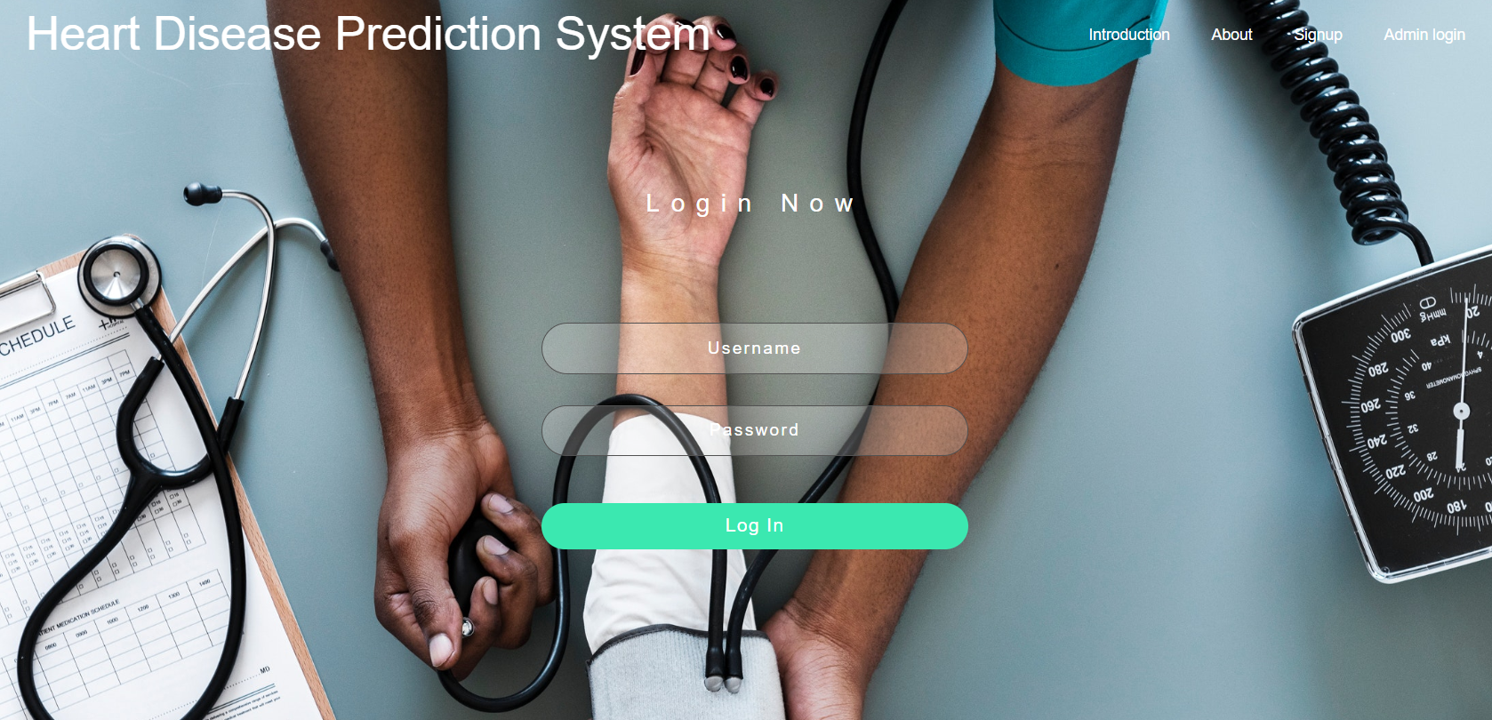

1. **register.html:**

{% load static %}

<html>

<head>

<title></title>

</head>

<body>

<div class="section section-signup" style="background-image: url('{% static 'images/GmrQcB.jpg' %}'); background-size: cover; background-position: top center; min-height: 720px;">

<nav class="navbar navbar-expand-lg fixed-top navbar-transparent" >

<div class="container">

<div class="collapse navbar-collapse justify-content-end" id="navigation" >

<ul class="navbar-nav nav-tabs">

<li class="nav-item"><a href="{% url 'about' %}" class="btn btn-neutral">About</a></li>

{%if user.is_authenticated%}

<li class="nav-item"><a href="{% url 'accounts:logout'%}" class="btn btn-neutral">Logout</a></li>{%else%}

<li><a href="{% url 'user_login' %}" class="btn btn-neutral">Login</a></li>{%endif%}

<li class="nav-item"><a href="/admin" class="btn btn-neutral">Admin login</a></li>

</ul>

</div>

</div>

</nav>

<div class="container">

<div class="row">

<div class="card-signup card-plain" data-background-color="">{% if registered %}

<h1>Thank you for registering!</h1>{% else %}

<form role="form" enctype="multipart/form-data" method="post">{% csrf_token %}

<div class="card-header text-center form-group">

<h3 class="card-title title-up ">Sign Up</h3>

{{ user_form}}{{ profile_form}}

<button type="submit" class="btn btn-round bg-transparent border">Sign Up</button>

</form>{% endif %}

</div>

</div>

</div>

</div>

</div>

</div>

</body>

</html>

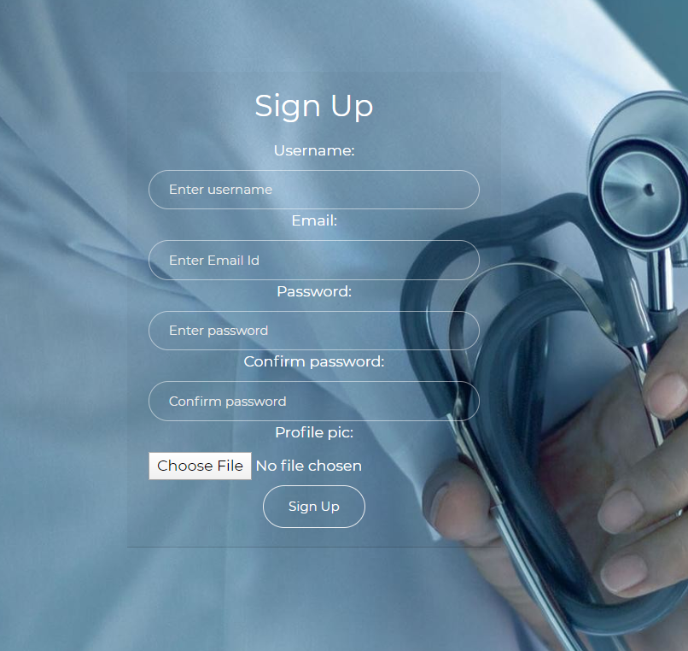

1. **predict.html:**

{% load static %}

<html>

<head>

<title>Medical Emergency </title>

</head>

<body>

<nav class="navbar navbar-expand-lg navbar-transparent">

<div class="container">

<div class="collapse navbar-collapse justify-content-end" id="navigation" >

<ul class="navbar-nav nav-tabs">

<li class="nav-item"><a href="{% url 'predict:predict' pk=user_id %}" class="btn btn-neutral">PREDICT</a></li>

<li class="nav-item"><a href="{% url 'accounts:profile' pk=user_id %}" class="btn btn-neutral">PROFILE</a></li>

<li class="nav-item"><a href="{% url 'accounts:logout' %}" class="btn btn-neutral">LOGOUT</a></li>

</ul>

</div>

</div>

</nav>

<h1 style="color: white">Predict your Heart disease</h1>

<div class="bg-agile">

<div class="book-appointment">

<h2>Medical Information</h2>{% if predicted %}

<h1 style="color:#fff;">Predictions</h1>

<nav class="navbar navbar-expand-lg navbar-transparent">

<div class="container">

<div class="collapse navbar-collapse justify-content-end" id="navigation" >

<ul class="navbar-nav nav-tabs">{% if result %}

<li class="nav-item"><a href="{% url 'accounts:recommendation' %}" class="btn btn-neutral">RECOMMENDATED DOCTORS</a></li>{% endif %}

</ul>

</div>

</div>

</nav>

<div class="card" role="alert">

<div class="header-main">{% if result %}

<h4 class="table-danger text-center" style="color:red;">You have a risk of HEART DISEASE</h4>{% else %}

<h4 class="table-success text-center" style="color:blue;">You do not have a risk of HEART DISEASE</h4>{% endif %}

</div>

<div class="card-body">

<div class="table-responsive justify-content-center">

<table class="table">

<thead>

<tr>

<th>Algorithm</th>

<th>Risk of Heart Disease</th>

</tr>

</thead>

<tbody>

<tr class="{{colors.LR}}">

<td>Logistic Regression</td>

<td>{{predictions.LogisticRegression}}</td>

</tr>

<tr class={{colors.SVC}}>

<td>Support Vector Classifier</td>

<td>{{predictions.SVC}}</td>

</tr>

<tr class={{colors.NB}}>

<td>Naive Bayes</td>

<td>{{predictions.NaiveBayes}}</td>

</tr>

<tr class={{colors.DT}}>

<td>Decision Tree</td>

<td>{{predictions.DecisionTree}}</td>

</tr>

<tr class={{colors.XGB}}>

<td> XGBClassifier </td>

<td>{{predictions.Boostxg}}</td>

</tr>

<tr class={{colors.RF}}>

<td> Random Forest Classifier </td>

<td>{{predictions.RandomForest}}</td>

</tr>

</tbody>

</table>

</div>

</div>

</div>{% endif %}

<form method="post">{% csrf_token %}

<div class="left-agileits-w3layouts same">

<div class="gaps">

<p>Age<p>{{form.age}}

</div>

<div class="gaps">

<p>Gender</p>{{form.sex}}

</div>

<div class="gaps">

<p>Chest Pain</p>{{form.chest_pain}}

</div>

<div class="gaps">

<p>Resting BP</p>{{form.resting_bp}}

</div>

<div class="gaps">

<p>Serum Cholestrol</p>{{form.serum_cholesterol}}

</div>

<div class="gaps">

<p>Fasting Blood Sugar</p>{{form.fasting_blood_sugar}}

</div>

<div class="gaps">

<p>Resting Electrocardiographic Result</p>{{form.resting_ecg}}

</div>

<div class="gaps">

<p>Maximum Heart Rate</p>{{form.max_heart_rate}}

</div>

<div class="gaps">

<p>Excercise Induced Angina</p>

{{form.exercise_induced_angina}}

</div>

<div class="gaps">

<p>ST Depression</p>{{form.st_depression}}

</div>

</div>

<div class="right-agileinfo same">

<div class="gaps">

<p>Slope of the peak exercise ST segment </p>

{{form.st_slope}}

</div>

<div class="gaps">

<p>Number of major vessels (0-3) colored by flourosopy</p>{{form.number_of_vessels}}

</div>

<div class="gaps">

<p>Thalium Scan Results</p>

{{form.thallium_scan_results}}

</div>

</div>

<div class="clear"></div>

<input type="submit" value="Predict" class="btn btn-primary">

</form>

</div>

</div>

<script type="text/javascript" src="js/jquery-2.1.4.min.js"></script>

<link rel="stylesheet" href="css/jquery-ui.css" />

<script src="js/jquery-ui.js"></script>

</body>

</html>

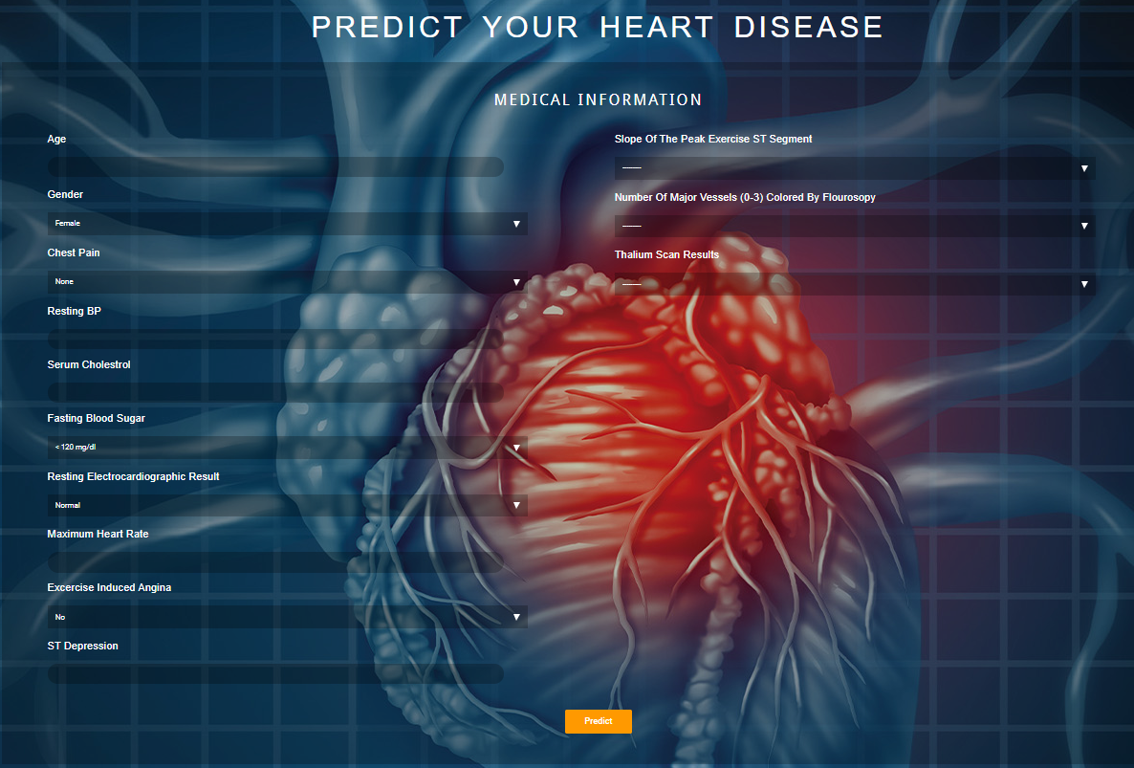

1. **intro.html:**

{% load static %}

<html lang="en">

<head>

<title>Introduction</title>

</head>

<body><div class="wrapper"><div class="page-header page-header-small "><div class="page-header-image" data-parallax="true" style="background-image: url('{% static 'images/heart_leaves.jpg' %}');"></div><div class="container"><div class="content-center"><div class="hero-text-box"><h1>Heart Disease Prediction &mdash; <br> Dataset &mdash; Classification with various models. </h1><a class="btn btn-ghost" href="{% url 'about' %}">About</a><a class="btn btn-ghost" href="{% url 'accounts:register'%}">Sign Up</a><a class="btn btn-ghost" href="{% url 'user_login' %}">Login</a></div></div></div></div><div class="section-features"><div class="row"><h2>About Dataset &mdash; Introduction</h2><p class="long-copy">Heart disease describes a range of conditions that affect your heart.Diseases under the heart disease umbrella include blood vessel diseases, such as coronaryartery disease, heart rhythm problems (arrhythmias) and heart defects you’re born with(congenital heart defects), among others. <br><br>The term “heart disease” is often used interchangeably with the term “cardiovascular disease”. Cardiovascular disease generally refers to conditions that involve narrowed or blocked blood vessels that can lead to a heart attack, chest pain(angina) or stroke. Other heart conditions, such as those that affect your heart’s muscle,valves or rhythm, also are considered forms of heart disease.<br><br><strong class="bold">About 610,000 people die of heart disease in the United States every year–that’s 1 in every 4 deaths. Heart disease is the leading cause of death for both men and women. More than half of the deaths due to heart disease in 2009 were in men.<br><br>Coronary Heart Disease(CHD) is the most common type of heart disease, killing over 370,000 people annually.<br><br>Every year about 735,000 Americans have a heart attack. Of these, 525,000 are a first heart attack and 210,000 happen in people who have already had a heart attack.</strong><br><br>This makes heart disease a major concern to be dealt with. But it is difficult to identify heart disease because of several contributory risk factors such as diabetes, high blood pressure, high cholesterol, abnormal pulse rate, and many other factors. Due to such constraints, scientists have turned towards modern approaches like Data Mining and Machine Learning for predicting the disease.<br><br>Machine learning (ML) proves to be effective in assisting in making decisions and predictions from the large quantity of data produced by the healthcare industry.<br><br>In this project, we will be applying Machine Learning algorithms included <a href="https://scikit-learn.org/stable/modules/generated/sklearn.svm.SVC.html" target="_blank">SupportVectorClassifier</a>, <a href="https://scikit-learn.org/stable/modules/generated/sklearn.tree.DecisionTreeClassifier.html" target="_blank">DecisionTreeClassifier</a>, <a href="https://scikit-learn.org/stable/modules/generated/sklearn.linear_model.LogisticRegression.html" target="_blank" >LogisticRegression</a> , <a href="https://scikit-learn.org/stable/modules/naive_bayes.html" target="_blank">NaiveBayesClassifier</a>, <a href="https://xgboost.readthedocs.io/en/latest/python/python_api.html" target="_blank">XgBoostClassifier</a> and <a href="https://scikit-learn.org/stable/modules/generated/sklearn.ensemble.RandomForestClassifier.html" target="_blank">RandomForestClassifier</a> for classifying whether a person is suffering from heart disease or not, using a dataset. </p></div><div class="row"><h2>The Data &mdash; Columns</h2><p class="long-copy">The dataset used in this project is the Cleveland Heart Disease dataset taken from the UCI repository. The dataset consists of 303 individuals data. There are 14 columns in the dataset, which are described below &mdash;</p></div></div><div class="hover"><div class="container"><div class="card"><div class="face face1"><div class="content"><h3>Displays the Age of an individual.</h3></div></div><div>class="faceface2"><divclass="content"><h2>AGE</h2></div></div></div><div class="card"><div class="face face1"><div class="content"><h3>Displays the Gender of anindividual.<br><br>1=male<br>0=female </h3></div></div><div>class="faceface2"><divclass="content"><h2>Sex</h2></div></div></div><div class="card"><div class="face face1"><div class="content"><h3>Displays the type of Chest-pain experienced by an individual: <br> <br>1 = typical angina <br>2 = atypical angina <br>3 = non-anginal pain <br>4 = asymptotic</h3></div></div><div class="face face2"><div class="content"><h2> <strong>Chest Pain Type</strong></h2></div></div></div><div class="card"><div class="face face1"><div class="content"><h3>Displays the resting blood pressure value in mmHg (unit)</h3></div></div><div class="face face2"><div class="content"><h2>Resting Blood Pressure</h2></div></div></div><div class="card"><div class="face face1"><div class="content"><h3>Displays the serum cholesterol in mg/dl (unit)</h3></div></div><div class="face face2"> <div class="content"><h2>Serum Cholestrol</h2></div></div></div><div class="card"><div class="face face1"><div class="content"><h3>Fasting blood sugar value with 120mg/dl. <br> <br>FBS>120mg/dl : 1(true) <br>else : 0(false)</h3></div></div><div class="faceface2"><divclass="content"<h2>FastingBlSugar</h2></div></div></div><div class="card"><div class="face face1"><div class="content"><h3>Displays resting electrocardiographic results <br> <br>0 = normal <br>1 = having ST-T wave abnormality <br>2 = left ventricular hyperthrophy</h3></div></div><div class="face face2"><div class="content"><h2>Resting ECG</h2></div></div></div><div class="card"> <div class="face face1"><div class="content"><h3>Displays the max heart rate achieved by an individual.</h3></div></div><divclass="faceface2"><divclass="content"><h2>MaximumHeart Rate achieved</h2></div></div></div><div class="card"><div class="face face1"><div class="content"><h3> 1 = Yes <br>0 = No</h3></div></div><div class="face face2"><div class="content"><h2>Induced Angina</h2</div></div></div><div class="card"><div class="face face1"><div class="content"><h3>Displays the value which is an integer or float.</h3></div> </div><div class="face face2"><div class="content"><h2>ST depression induced by exercise relative to rest</h2></div></div></div><div class="card"><div class="face face1"><div class="content"><h3>1 = upsloping <br>2 = flat <br>3 = downsloping</h3></div></div><div class="face face2"><div class="content"><h2>Peak exercise ST segment</h2></div></div></div><div class="card"><div class="face face1"><div class="content"><h3>Displays the value as integer or float.</h3></div></div><div class="face face2"><div class="content"><h2>Number of major vessels (0–3) colored by flourosopy </h2></div></div></div><div class="card"><div class="face face1"><div class="content"><h3>3 = normal <br>6 = fixed defect <br>7 = reversible defect</h3></div></div><div class="face face2"><div class="content"><h2>Thal</h2></div></div></div><div class="card"><div class="face face1"><div class="content"><h3>Displays whether the individual is suffering from heart disease or not: <br> <br>0 = Absence <br>1 = Present.</h3></div></div><div class="face face2"><div class="content"><h2>Diagnosis of heart disease</h2></div></div></div></div></div><div class="reason"><div class="row"><h2>This Parameters &mdash; Why?</h2><p class="long-copy">In the dataset, we had 76 features but for our study, we chose only the above 14 because:</p><li><ol><h3>Age :</h3><p class="long-copy">Age is the most important risk factor in developing cardiovascular or heart diseases, with approximately a tripling of risk with each decade of life. Coronary fatty streaks can begin to form in adolescence. It is estimated that 82 percent of people who die of coronary heart disease are 65 and older. Simultaneously, the risk of stroke doubles every decade after age 55.</p></ol><ol><h3>Sex: </h3> <p class="long-copy">Men are at greater risk of heart disease than pre-menopausal women.Once past menopause, it has been argued that a woman’s risk is similar to a man’s although more recent data from the WHO and UN disputes this. If a female has diabetes, she is more likely to develop heart disease than a male with diabetes.</p></ol><ol><h3>Angina (Chest Pain): </h3><p class="long-copy">Angina is chest pain or discomfort caused when your heart muscle doesn’t getenough oxygen-rich blood. It may feel like pressure or squeezing in your chest. The discomfort also can occur in your shoulders, arms, neck, jaw, or back. Angina pain may even feel like indigestion.</p></ol><ol><h3>Resting Blood Pressure: </h3> <p class="long-copy">Over time, high blood pressure can damage arteries that feed your heart.High blood pressure that occurs with other conditions, such as obesity, high cholesterol or diabetes, increases your risk even more.</p></ol><ol><h3>Serum Cholesterol: </h3><p class="long-copy">A high level of low-density lipoprotein (LDL) cholesterol (the “bad” cholesterol)is most likely to narrow arteries. A high level of triglycerides, a type of blood fat related to your diet, also ups your risk of a heart attack. However, a high level of high-density lipoprotein (HDL)cholesterol (the “good” cholesterol) lowers your risk of a heart attack.</p></ol><ol><h3>Fasting Blood Sugar: </h3><p class="long-copy">Not producing enough of a hormone secreted by your pancreas (insulin) or not responding to insulin properly causes your body’s blood sugar levels to rise, increasing your risk of a heart attack.</p></ol><ol><h3>Resting ECG: </h3><p class="long-copy">For people at low risk of cardiovascular disease, the USPSTF concludes with moderate certainty that the potential harms of screening with resting or exercise ECG equal or exceed the potential benefits. For people at intermediate to high risk, current evidence is insufficient to assess the balance of benefits and harms of screening.</p> </ol><ol><h3>Max heart rate achieved: </h3><p class="long-copy">The increase in cardiovascular risk, associated with the acceleration of heart rate, was comparable to the increase in risk observed with high blood pressure. It has been shown that an increase in heart rate by 10 beats per minute was associated with an increase in the risk of cardiac death by at least 20%, and this increase in the risk is similar to the one observed with an increase in systolic blood pressure by 10 mm Hg.</p></ol> <ol> <h3>Exercise induced angina: </h3> <p class="long-copy">The pain or discomfort associated with angina usually feels tight,gripping or squeezing, and can vary from mild to severe. Angina is usually felt in the center of your chest but may spread to either or both of your shoulders, or your back, neck, jaw or arm. It can even be felt in your hands. o Types of Angina a. Stable Angina / Angina Pectoris b. Unstable Angina c. Variant (Prinzmetal) Angina d. Microvascular Angina.</p></ol><ol> <h3>ST depression induced by exercise relative to rest: </h3> <p class="long-copy">It is often a sign of myocardial ischemia, of which coronary insufficiency is a major cause.In unstable coronary artery disease, ST-segment depression is associated with a 100% increase in the occurrence of three-vessel/left main disease and to an increased risk of subsequent cardiac events. In these patients an early invasive strategy substantially decreases death/myocardial infarction.</p> </ol> <ol> <h3>Peak exercise ST segment: </h3> <p class="long-copy">A treadmill ECG stress test is considered abnormal when there is a horizontal or down-sloping ST-segment depression ≥ 1 mm at 60–80 ms after the J point. Exercise ECGs with up-sloping ST-segment depressions are typically reported as an ‘equivocal’ test. In general, the occurrence of horizontal or down-sloping ST-segment depression at a lower workload (calculated in METs) or heart rate indicates a worse prognosis and higher likelihood of multi-vessel disease. The duration of ST-segment depression is also important, as prolonged recovery after peak stress is consistent with a positive treadmill ECG stress test. Another finding that is highly indicative of significant CAD is the occurrence of ST-segment elevation > 1 mm (often suggesting transmural ischemia); these patients are frequently referred urgently for coronary angiography.</p> </ol><ol> <h3>Number of major vessels (0–3) colored by flourosopy: </h3> <p class="long-copy">Heart scan (coronary calcium scan) A heart scan (coronary calcium scan) provides pictures of your heart's arteries. Doctors may use this test to look for calcium deposits in the coronary arteries that can narrow your arteries and increase your heart attack risk.The image on the right shows a coronary calcium scan.</p> </ol><ol><h3>Thal: </h3><p class="long-copy">Doctors diagnose thalassemias using blood tests, including a complete blood count (CBC) and special hemoglobin tests. A CBC measures the amount of hemoglobin and the different kinds of blood cells, such as red blood cells, in a sample of blood.</p> </ol> </li></div> </div><footer class="footer footer-default"><div class="container"><div class="about-us" data-aos="fade-right" data-aos-delay="200"><p> <a href="{% url 'user_login' %}">Login</a> | <a href="{% url 'intro' %}">Introduction</a> | <a href="{% url 'about' %}">About</a></p></div> <p></p><p> </p><p></p><div class="copyright"> Coded by Prafull, Priyam, Ritambhara, Sampriti and Rupak </div> </div><div class="move-up">

<span><i class="fas fa-arrow-circle-up fa-2x"></i></span></div></footer> </div></body><script src="{% static 'js/jquery.3.2.1.min.js' %}" type="text/javascript"></script><script src="{% static 'js/popper.min.js' %}" type="text/javascript"></script><script src="{% static 'js/bootstrap.min.js' %}" type="text/javascript"></script><script src="{% static 'js/bootstrap_ui_kit.js' %}" type="text/javascript"></script></html>

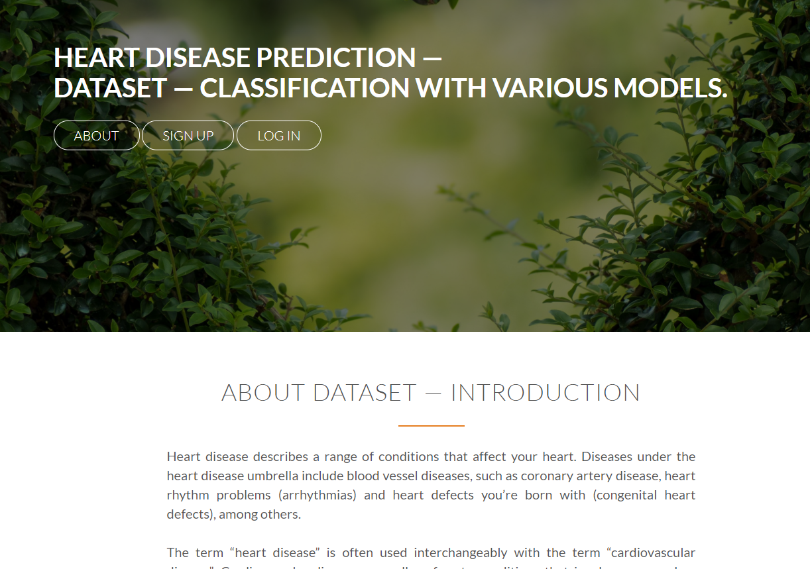



1. **about.html:**

{% load static %}

<html>

<head>

<title>Home</title>

</head>

<body class="landing-page sidebar-collapse"><nav class="navbar navbar-expand-lg bg-primary fixed-top navbar-transparent" color-on-scroll="400"><div class="container"><div class="navbar-translate"><a class="navbar-brand" ><h5>Heart Disease Analysis &amp; Prediction</h5></a></div><div class="collapse navbar-collapse justify-content-end" id="navigation" data-nav-image=""><ul class="navbar-nav"><li class="nav-item">{%if user.is_authenticated %}<a class="nav-link " href="{% url 'intro'%}">Introduction</a><a class="navlink"href="{%url'accounts:logout'%}">Logout</a>{%else%}{%endif%}</li></ul></div></div></nav><div class="wrapper"><div class="page-header page-header-small "><div class="page-header-image" data-parallax="true" style="background-image: url('{% static 'images/image99.jpg' %}');"></div><div class="container"><div class="content-center"><h1 class="title">Predict your chance of having a heart disease because prevention is better than cure!</h1><div class="text-center"><a href="{% url 'accounts:register'%}"class="btnbtndangerborderbtnround"><h6>Signup</h6></a><ahref="{%url'user_login'%}"class="btnbtndangerborderbtnround"><h6>Login</h6></a></div></div></div></div><div class="section section-about-us"><div class="container"><div class="row"><div class="col-md-8 ml-auto mr-auto text-center"><h2 class="title">About Us</h2><h5 class="description"><strong>Loads of features. Making it easier for anyone to predict the chance of getting heart disease. Shows analysis done on large data sets.</strong></h5></div></div><div class="separator separator-primary"></div><div class="section-story-overview"><div class="row"><div class="col-md-6"><div class="image-container image-left" style="background-image: url('{% static 'images/1.jpg' %}')"><p class="blockquote blockquote-primary">"65% of medical professionals believe increased technology adoption will result in better patient outcome."<br><br><small>– GERMAIN CHASTEL,<br>CEO and Founder of NewtonX.</br></small></p></div><div class="image-container" style="background-image: url('{% static 'images/django2.jpg' %}')"></div></div><div class="col-md-5"><div class="image-container image-right" style="background-image: url('{% static 'images/heart.jpg' %}')"></div><h3 style="color:blue">Vast and Reliable Dataset</h3><p> This database contains 76 attributes, but all published experiments refer to using a subset of 14 of them. In particular, theClevelanddatabaseistheonlyonethathasbeenusedbyMLresearcherstothisdate.</p><br><br><br><br><h3 style="color:blue">Analysis & Prediction Using Python and Django Framework</h3><p>The code used for analysis of data and getting prediction rates is prettysimple.ThecodeiswritteninPythonandDjangoatAtomplatfrom.</p></div></div></div></div></div><div class="section section-team text-center"><div class="container"><h2 class="title">Here is our team</h2><div class="team"><div class="row"><div class="col-md-4"><div class="team-player"><img src="{% static 'images/Prafull2.jpeg' %}" alt="Thumbnail Image" class="rounded-circle img-fluid img-raised"><h4 class="title">Prafull Kumar</h4><p class="category text-primary">Student<br>CSE2(4th year)</p><a href="https://github.com/codeFriend7/" target="_blank" class="btn btn-primary btn-icon btn-round"><i class="fa fa-github"></i></a><a href="#" class="btn btn-primary btn-icon btn-round"><i class="fa fa-instagram"></i></a><a href="https://www.facebook.com/prafull.kumar.54584" target="_blank" class="btn btn-primary btn-icon btn-round"><i class="fa fa-facebook-square"></i></a></div></div><div class="col-md-4"><div class="team-player"><img src="{% static 'images/Priyam.jpeg' %}" alt="Thumbnail Image" class="rounded-circle img-fluid img-raised"><h4 class="title">Priyam Halder</h4><p class="category text-primary">Student<br>CSE2(4th year)</p><a href="#" class="btn btn-primary btn-icon btn-round"><i class="fa fa-google-plus"></i></a><a href="#" class="btn btn-primary btn-icon btn-round"><i class="fa fa-instagram"></i></a><a href="#" class="btn btn-primary btn-icon btn-round"><i class="fa fa-facebook-square"></i></a></div></div><div class="col-md-4"><div class="team-player"><img src="{% static 'images/Ritambhara.jpeg' %}" alt="Thumbnail Image" class="rounded-circle img-fluid img-raised"><h4 class="title">Ritambhara Chatterjee</h4><p class="category text-primary">Student<br>CSE2(4th year)</p><a href="#" class="btn btn-primary btn-icon btn-round"><i class="fa fa-google-plus"></i></a><a href="#" class="btn btn-primary btn-icon btn-round"><i class="fa fa-instagram"></i></a><a href="#" class="btn btn-primary btn-icon btn-round"><i class="fa fa-facebook-square"></i></a></div></div><div class="col-md-6"><div class="team-player"><img src="{% static 'images/Rupak.jpeg' %}" alt="Thumbnail Image" class="rounded-circle img-fluid img-raised"><h4 class="title">Rupak Dey</h4><p class="category text-primary">Student<br>CSE2(4th year)</p><a href="#" class="btn btn-primary btn-icon btn-round"><i class="fa fa-google-plus"></i></a><a href="https://github.com/Rupak240" target="_blank" class="btn btn-primary btn-icon btn-round"><i class="fa fa-github"></i></a><a href="#" class="btn btn-primary btn-icon btn-round"><i class="fa fa-facebook-square"></i></a></div></div><div class="col-md-6"><div class="team-player"><img src="{% static 'images/Sampriti.jpeg' %}" alt="Thumbnail Image" class="rounded-circle img-fluid img-raised"><h4 class="title">Sampriti Ghosh</h4><p class="category text-primary">Student<br>CSE2(4th year)</p><a href="#" class="btn btn-primary btn-icon btn-round"><i class="fa fa-google-plus"></i></a><a href="#" class="btn btn-primary btn-icon btn-round"><i class="fa fa-github"></i></a><a href="#" class="btn btn-primary btn-icon btn-round"><i class="fa fa-facebook-square"></i></a></div></div></div></div></div></div><footer class="footer footer-default"><div class="container"><nav></nav><div class="copyright">&copy; 2020,Coded by Prafull,Priyam and Rupak</div></div></footer></div></body><script src="{% static 'js/jquery.3.2.1.min.js' %}" type="text/javascript"></script><script src="{% static 'js/popper.min.js' %}" type="text/javascript"></script><script src="{% static 'js/bootstrap.min.js' %}" type="text/javascript"></script><script src="{% static 'js/bootstrap_ui_kit.js' %}" type="text/javascript"></script></html>

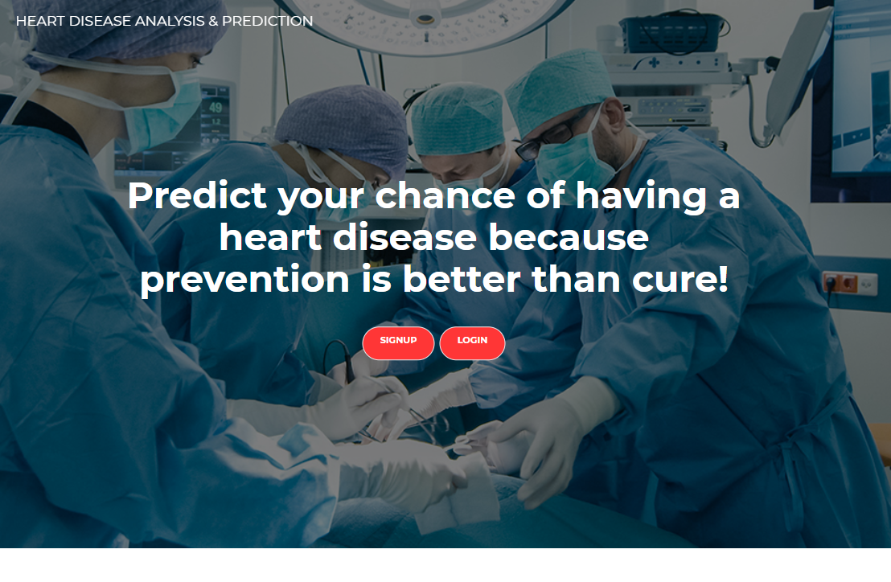

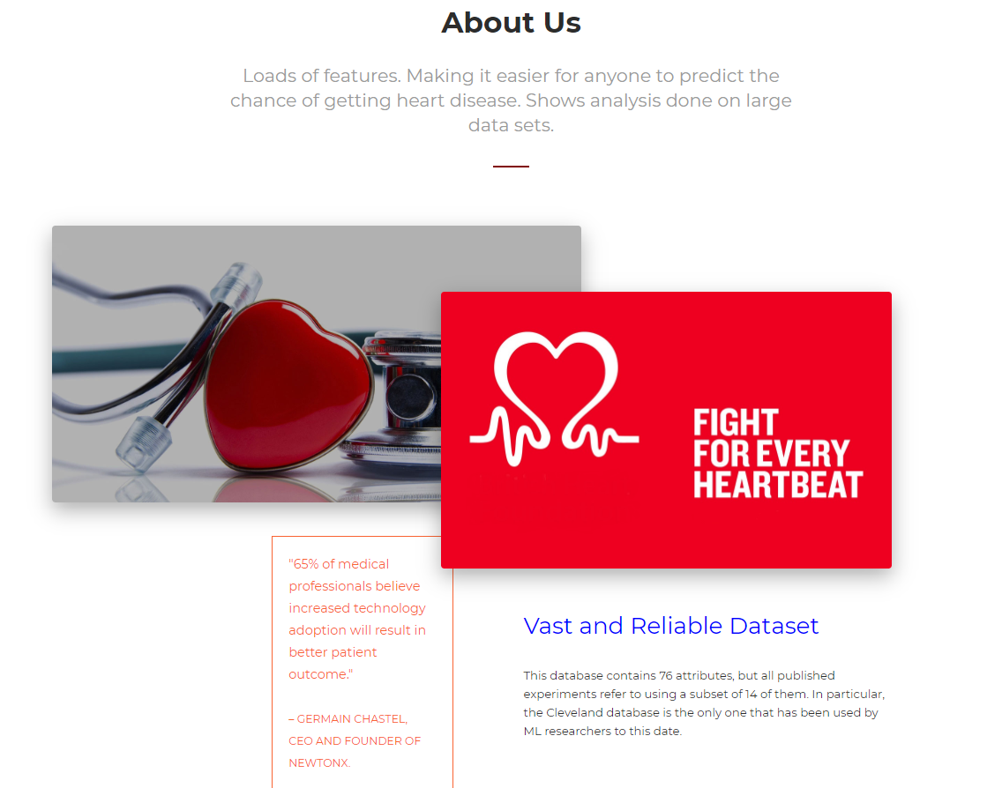

1. **profileview.html:**

{% load static %}

<html>

<head><title>UserProfileDetails</title></head>

<body class="profile-page sidebar-collapse"><nav class="navbar navbar-expand-lg bg-primary fixed-top navbar-transparent" color-on-scroll="400" ><div class="container"><div class="collapse navbar-collapse justify-content-end" id="navigation" data-nav-image=""><ul class="nav nav-tabs" data-tabs="tabs"><li class="nav-item"><a href="{% url 'predict:predict' pk=user_id %}" class="btn btn-neutral">Predict</a></li><li class="nav-item"><a href="{% url 'about'%}" class="btn btn-neutral">About</a></li><li class="nav-item"><a href="{% url 'accounts:logout'%}" class="btn btn-neutral">Logout</a></li></ul></div></div></nav><div class="wrapper"><div class="page-header page-header-small" filter-color="orange" style="max-height: 100px;"><div class="page-header-image" data-parallax="true" style="background-image: url('{% static 'images/fav.jpg' %}'); "></div><div class="container"><div class="content-center"><div class="photo-container"><img src="{{userprofileinfo.profile_pic.url}}" /></div><h3 class="title">{{ userprofileinfo.user.username }}</h3><p class="h5">{{ userprofileinfo.user.email }}</p></div></div></div></div><div class="section"><div class="container"><div class="button-container"><i class="fa fa-github"></i></a></div></div></div><div class="container"><div class="card-header bg-warning btn-round text-white">Predictions</div><hr>{% for pred in userprofileinfo.predict.all %}<br><div class="card card-login" style="width: 100%"><div class="card-header bg-dark text-white" style="height: 50px,;"> Prediction : {{ pred.num|safe}}</div><div class="container"><br><p>Age: {{pred.age}}</p><p>Gender: {{pred.sex}}</p><p>Chest Pain Type: {{pred.cp}}</p><p>Blood Pressure: {{pred.resting_bp}}</p><p>Cholestoral: {{pred.serum_cholesterol}}</p><p>Blood Sugar: {{pred.fasting_blood_sugar}}</p><p>ECG Result: {{pred.resting_ecg}}</p><p>Maximum Heart Rate: {{pred.max_heart_rate}}</p><p>Exercise Induced Angina: {{pred.exercise_induced_angina}}</p><p>ST_Depression: {{pred.st_depression}}</p><p>ST_Slope: {{pred.st_slope}}</p><p>No of Vessels: {{pred.number_of_vessels}}</p><p>Thallium Scan Results: {{pred.thallium_scan_results}}</p></div><div class="card-footer bg-light" >Predicted on {{ pred.predicted_on }}</div></div><br>{% endfor %}</div></body><script src="{% static 'js/jquery.3.2.1.min.js' %}" type="text/javascript"></script><script src="{% static 'js/popper.min.js' %}" type="text/javascript"></script><script src="{% static 'js/bootstrap.min.js' %}" type="text/javascript"></script><script src="{% static 'js/bootstrap_ui_kit.js' %}" type="text/javascript"></script></html>

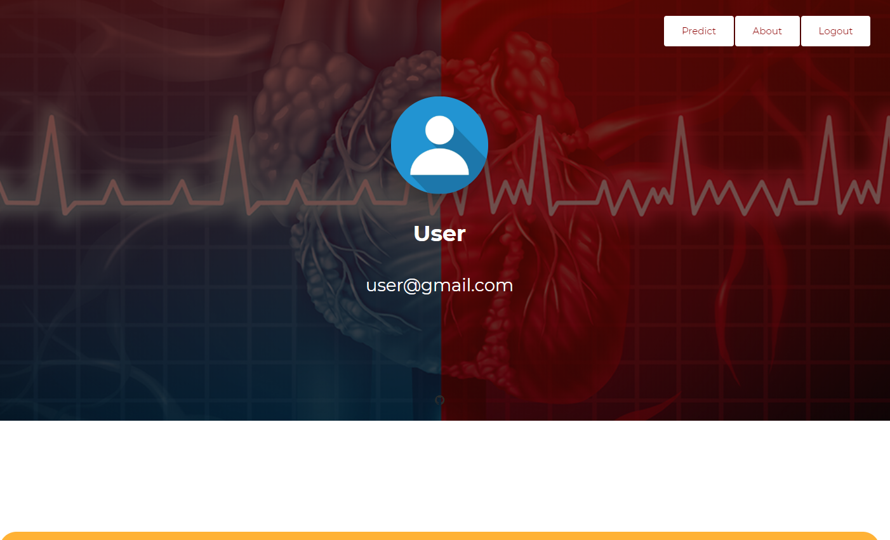

1. **recommendation.html:**

{% load static %}

<html>

<head>

<title>Recommendation</title>

</head>

<body>

<div class="main">

<section class="header">

<nav class="navbar navbar-expand-lg navbar-light">

<a class="navbar-brand" href="#"> <h1> <a href="{% url 'accounts:recommendation' %}">RECOMMENDATED DOCTORS</a> </h1> </a>

<button class="navbar-toggler" type="button" data-toggle="collapse" data-target="#navbarNav" aria-controls="navbarNav" aria-expanded="false" aria-label="Toggle navigation">

<span class="navbar-toggler-icon"></span>

</button>

<div class="collapse navbar-collapse" id="navbarNav">

<ul class="navbar-nav ml-auto">

<li class="nav-item">

<a class="nav-link" href="{% url 'intro' %}">

INTRODUCTION</a></li>

<li class="nav-item">

<a class="nav-link" href="{% url 'about' %}">ABOUT</a>

</li>

<li class="nav-item">

<a class="nav-link" href="https://www.practo.com/kolkata/cardiologist" target="_blank">SEE MORE</a></li>

<li class="nav-item">

<a class="nav-link" href="{% url 'accounts:logout'%}">LOGOUT</a></li>

</ul>

</div></nav>

</section>

</div>

<div class="body">

<div class="container">

<div class="box">

<div class="content">

<h4>{{ doctor11 }}</h4> <br>

<h4>{{ doctor12 }}</h4><br>

<h4>{{ doctor13 }}</h4><br>

<h4>{{ doctor14 }}</h4><br></div>

</div>

<div class="box">

<div class="content">

<h4>{{ doctor21 }}</h4> <br>

<h4>{{ doctor22 }}</h4><br>

<h4>{{ doctor23 }}</h4><br>

<h4>{{ doctor24 }}</h4><br></div>

</div>

<div class="box">

<div class="content">

<h4>{{ doctor31 }}</h4> <br>

<h4>{{ doctor32 }}</h4><br>

<h4>{{ doctor33 }}</h4><br>

<h4>{{ doctor34 }}</h4><br>

</div></div>

</div><svg>

<filter id="wavy">

<feTurbulence x="0" y="0" id="turbulence" baseFrequency="0.01" numOctaves="5" seed="2">

<animate attributeName="baseFrequency" dur="60s" values="0.01;0.05;0.01" repeatCount="indefinite" />

</feTurbulence>

<feDisplacementMap in="SourceGraphic" scale="30" />

</filter></svg></div>

</body>

</html>/></filter></svg></div></body></html>

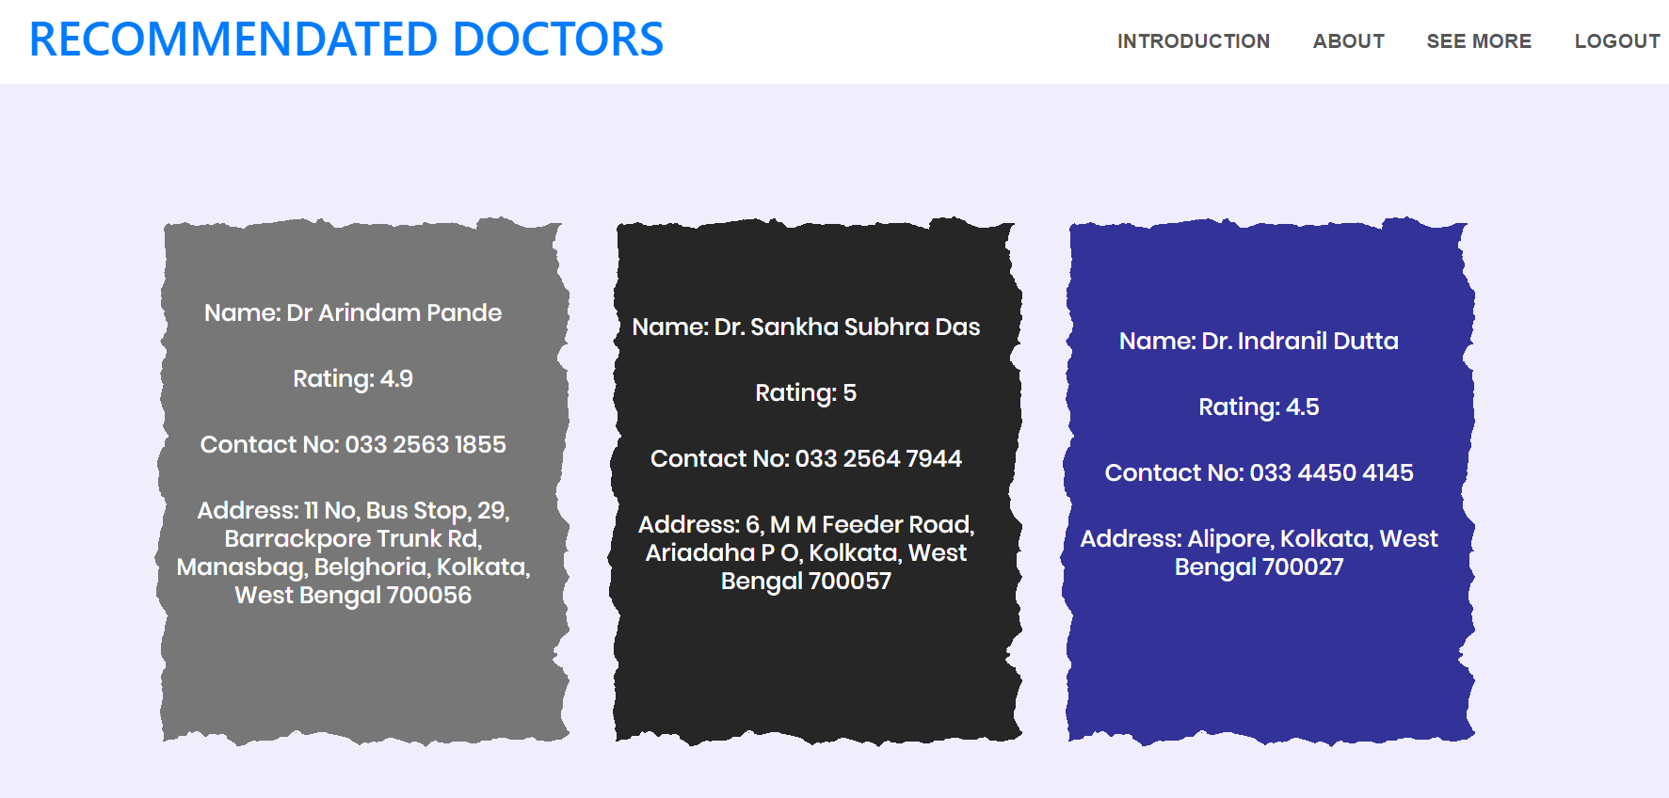

Experimental Results

1. **Test case I Results and Screenshots:**

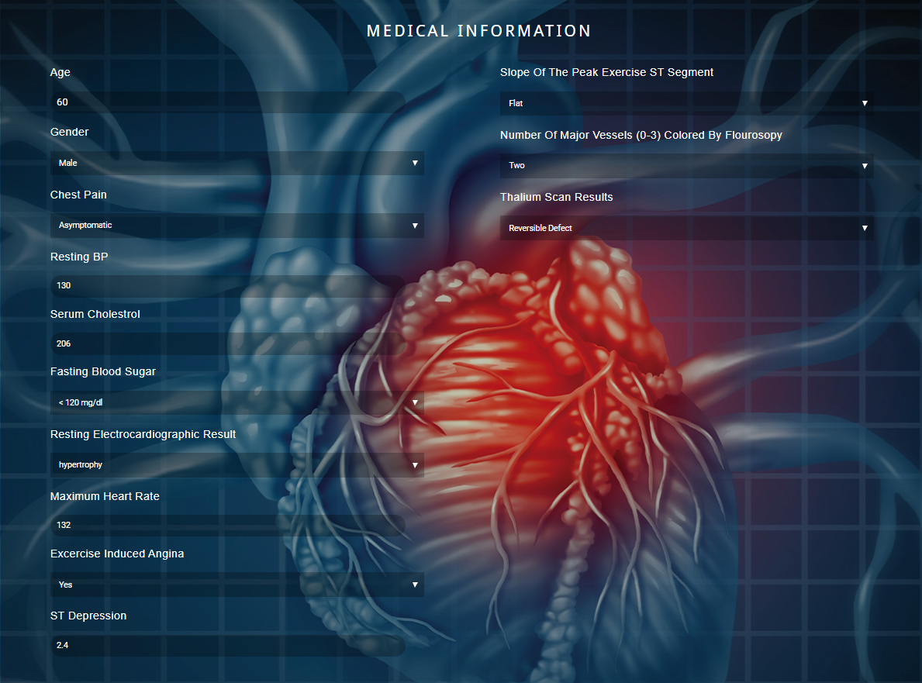

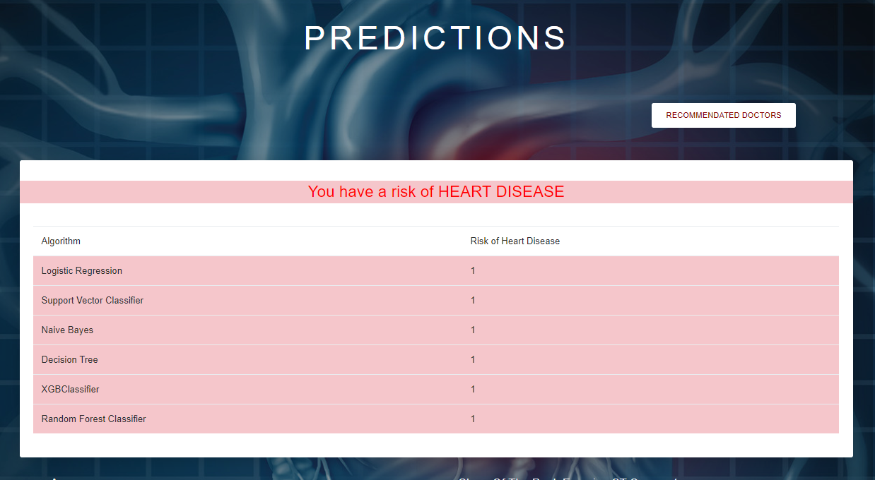

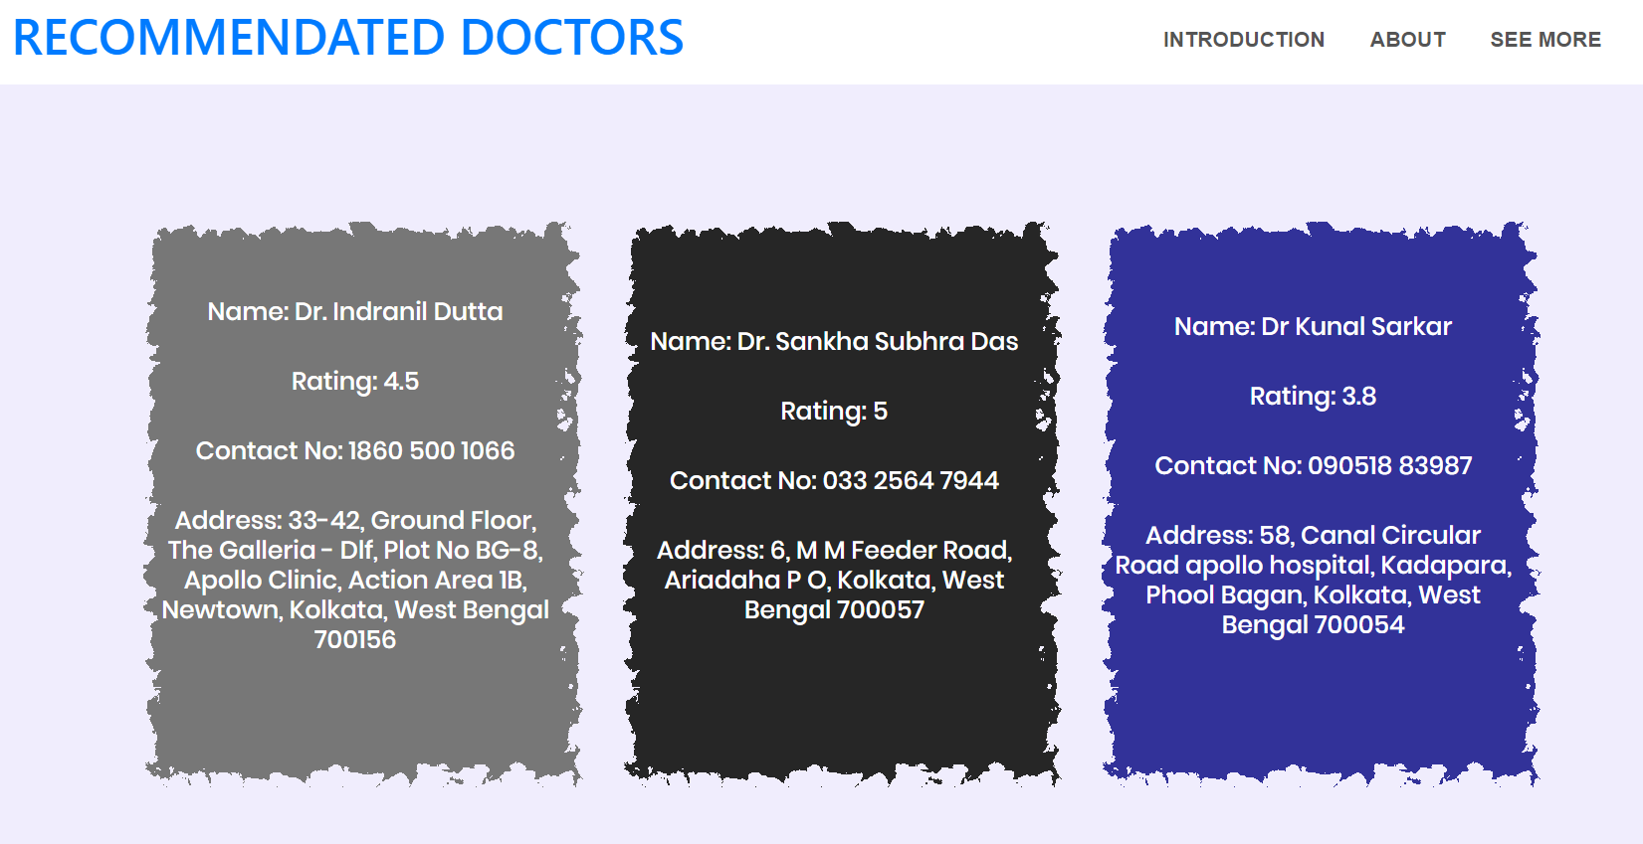

1. **Test Case II Results and Screenshots:**

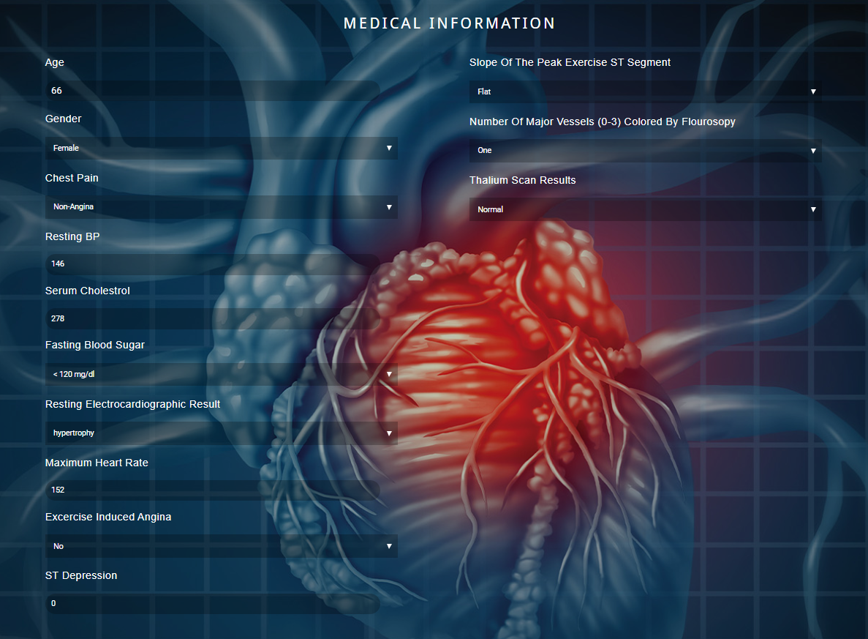

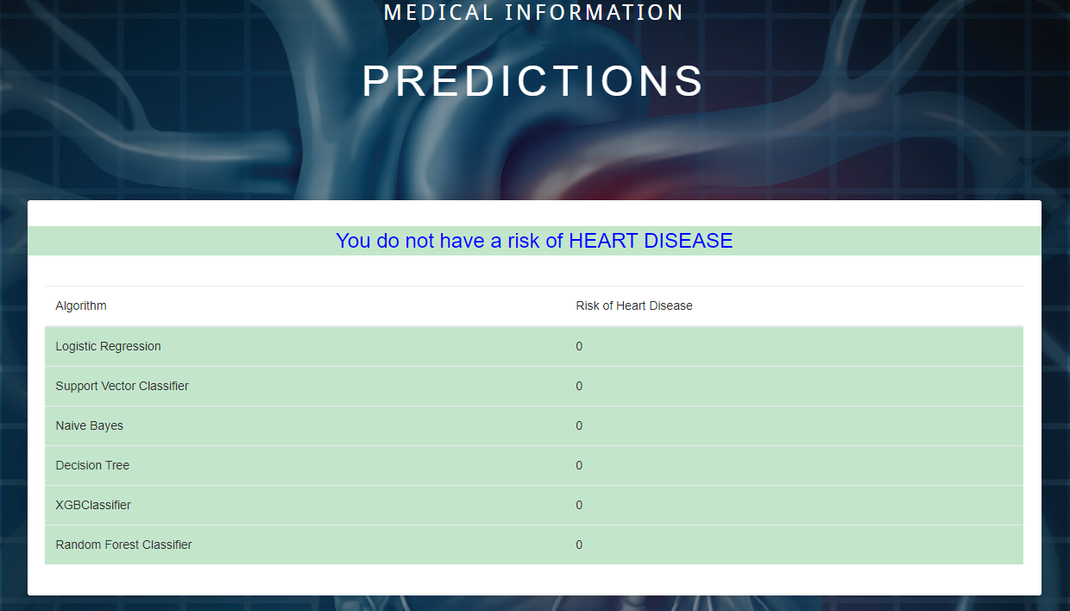

1. **Test Case III Results and Screenshots:**

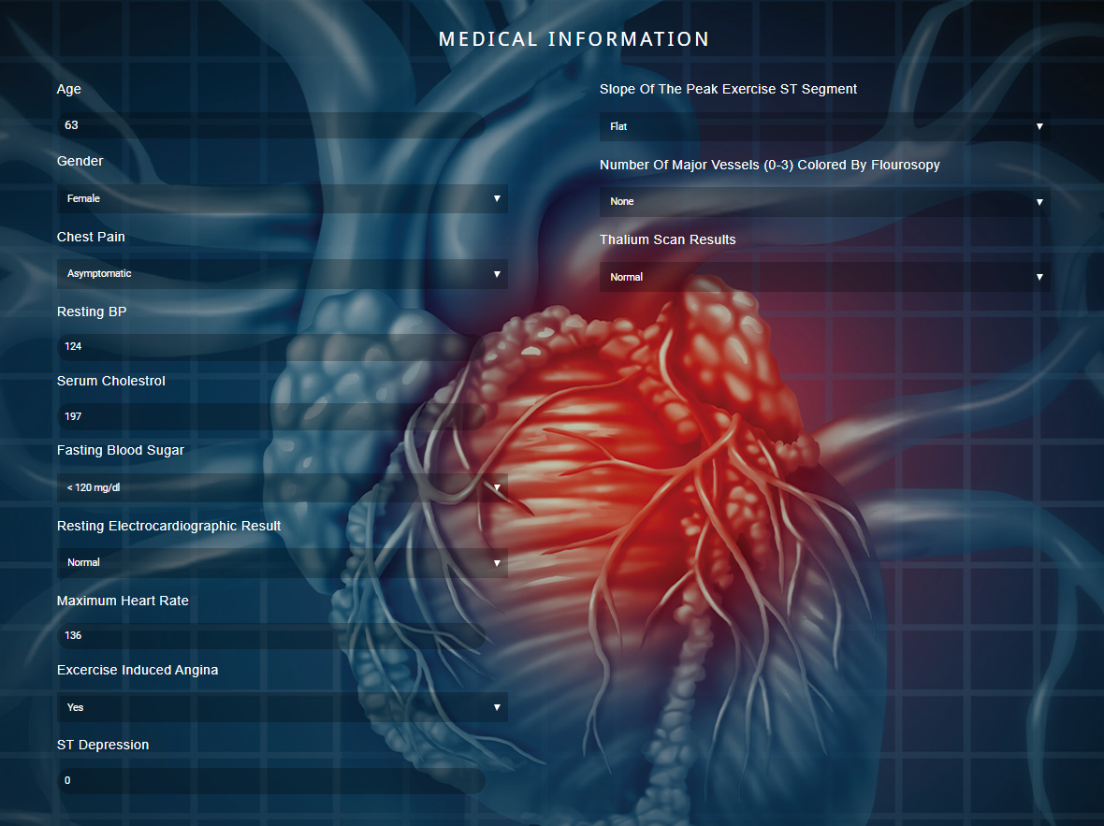

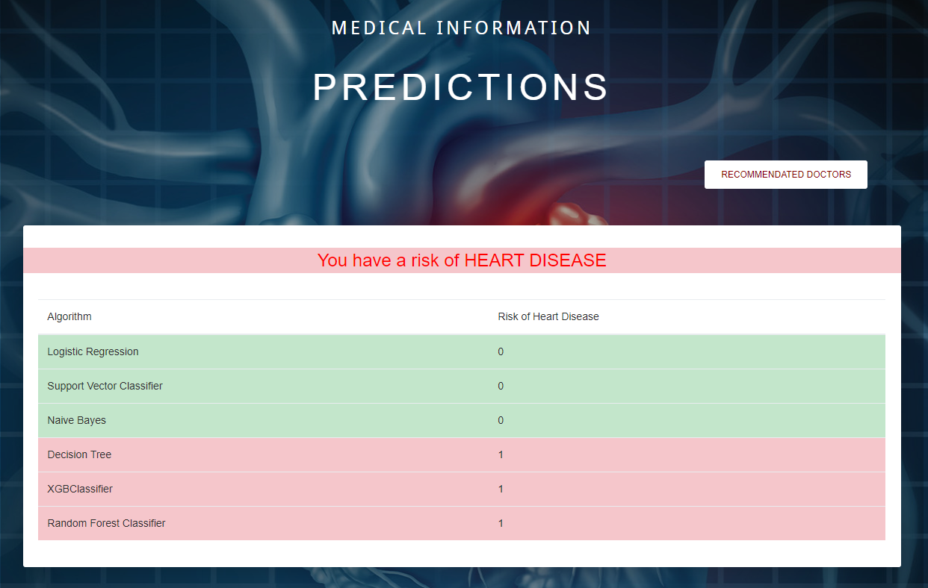

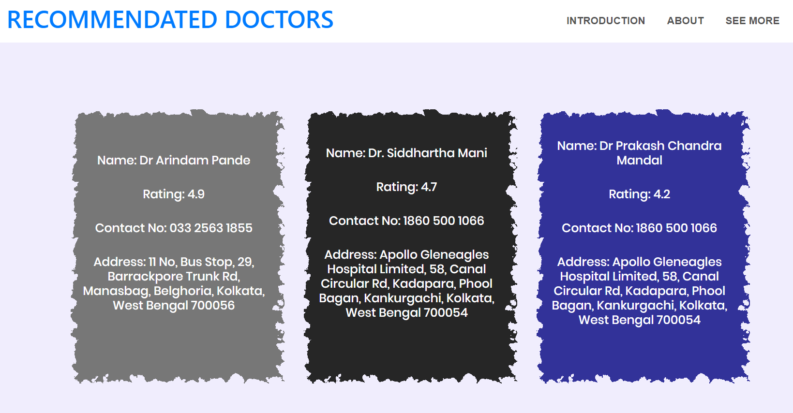

Conclusion & Future Study

1. A, A. S., & Naik, C. (2016). Different Data Mining Approaches for Predicting Heart Disease, 277– 281. https://doi.org/10.15680/IJIRSET.2016.0505545

**References**

1. Beyene, C., & Kamat, P. (2018). Survey on prediction and analysis the occurrence of heart disease using data mining techniques. International Journal of Pure and Applied Mathematics, 118(Special Issue 8), 165–173. Retrieved from https://www.scopus.com/inward/record.uri?eid=2-s2.085041895038&partnerID=40&md5=2f0b0c5191a82bc0c3f0daf67d73bc1
2. Brownlee, J. (2016). Naive Bayes for Machine Learning. Retrieved March 4, 2019, from https://machinelearningmastery.com/naive-bayes-for-machine-learning/
3. Kirmani, M. (2017). Cardiovascular Disease Prediction using Data Mining Techniques. Oriental Journal of Computer Science and Technology, 10(2), 520–528. https://doi.org/10.13005/ojcst/10.02.38
4. Polaraju, K., Durga Prasad, D., & Tech Scholar, M. (2017). Prediction of Heart Disease using Multiple Linear Regression Model. International Journal of Engineering Development and Research, 5(4), 2321–9939. Retrieved from www.ijedr.org
5. Purushottam, Saxena, K., & Sharma, R. (2016). Efficient Heart Disease Prediction System. In Procedia Computer Science (Vol. 85, pp. 962–969). https://doi.org/10.1016/j.procs.2016.05.288
6. Sai, P. P., & Reddy, C. (2017). International Journal of Computer Science and Mobile Computing HEART DISEASE PREDICTION USING ANN ALGORITHM IN DATA MINING. International Journal of Computer Science & Mobile Computing, 6(4), 168–172. Retrieved from www.ijcsmc.com
7. Science, C., & Faculty, G. M. (2009). Heart Disease Prediction Using Machine learning and Data Mining Technique. Ijcsc 0973-7391, 7, 1–9.
8. Soni, J., Ansari, U., & Sharma, D. (2011). Intelligent and Effective Heart Disease Prediction System using Weighted Associative Classifiers. Heart Disease, 3(6), 2385–2392.
9. Sultana, M., Haider, A., & Uddin, M. S. (2017). Analysis of data mining techniques for heart isease prediction. In 2016 3rd International Conference n Electrical Engineering and Information and Communication Technology, iCEEiCT 2016 (pp. 1–5). https://doi.org/10.1109/CEEICT.2016.7873142